**CTF – OCTOBER 10**

**WE ARE TELNETTED! : DIGITAL FORENSICS**

QUES: Some mischievous intruder thought telnet was still cool, but they left a 'login trail' behind. Your mission: Find the hacker's 'login name' from the attached pcap file and bring them to justice! "HINT: Include ans in SAIT’SCTF{----}

ANS: SAIT’SCTF{tteesstt}

SOLUTION:

* Following the stream.

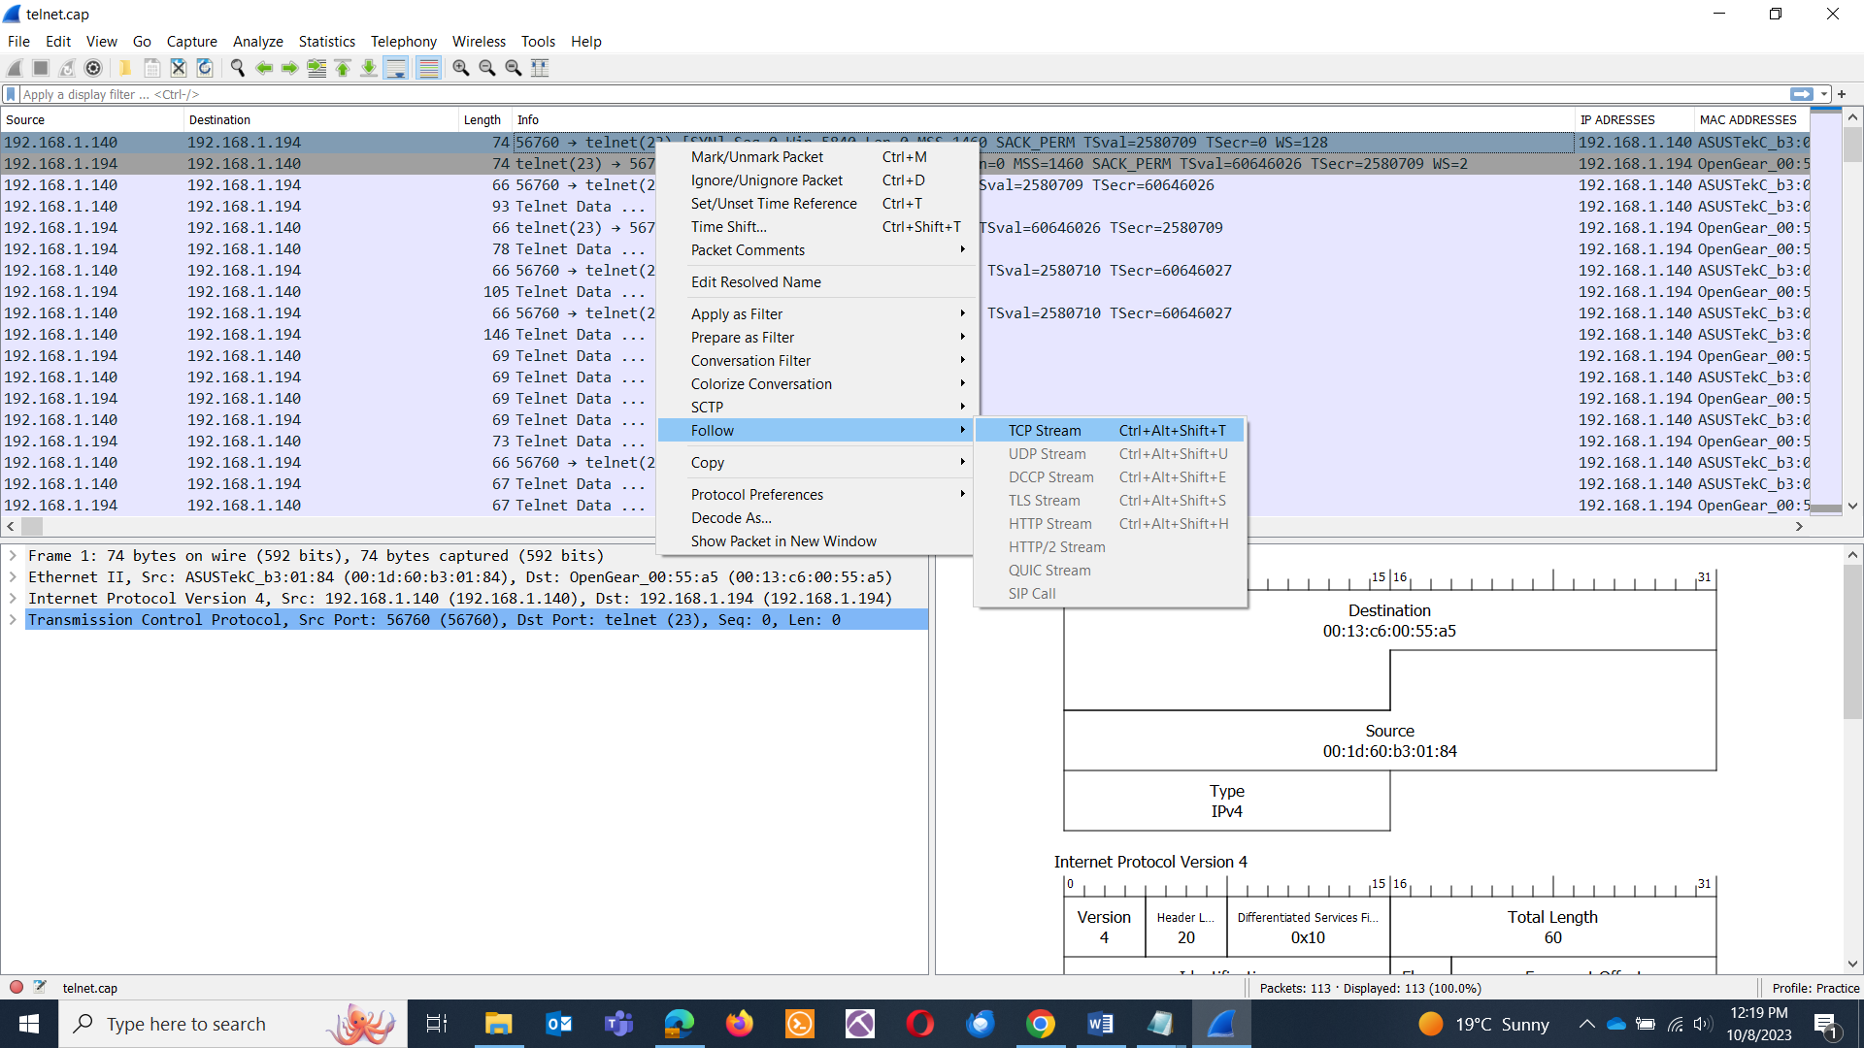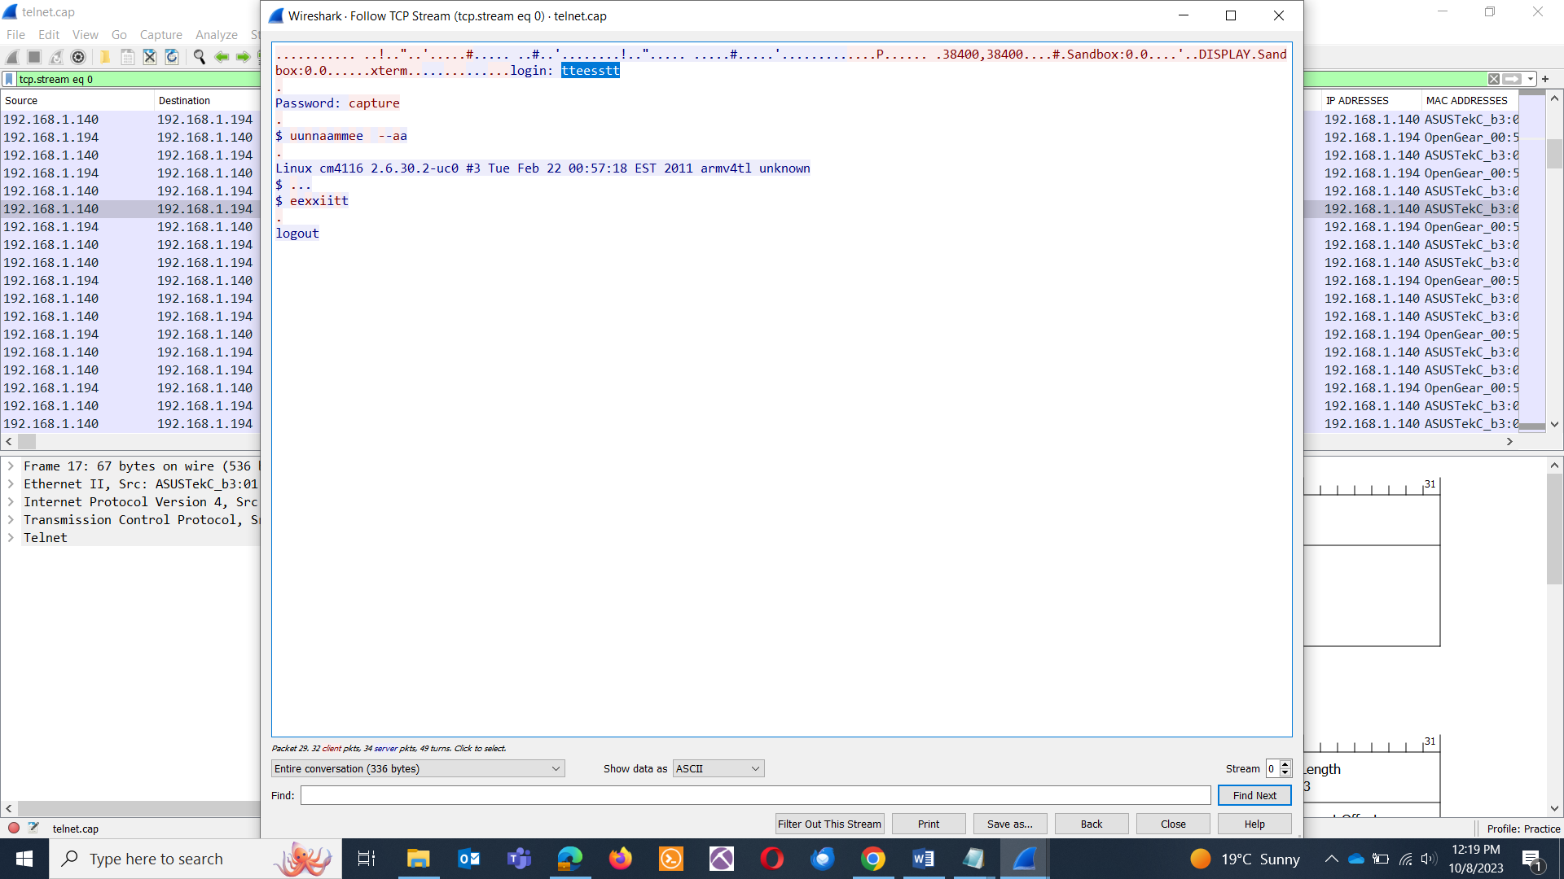

**WHAT IS WEIRD : DIGITAL FORENSICS**

QUES:Find the flag in the picture.

Image: Building.jpg

ANS: SAIT'SCTF{Barbie}

TOOL: bless

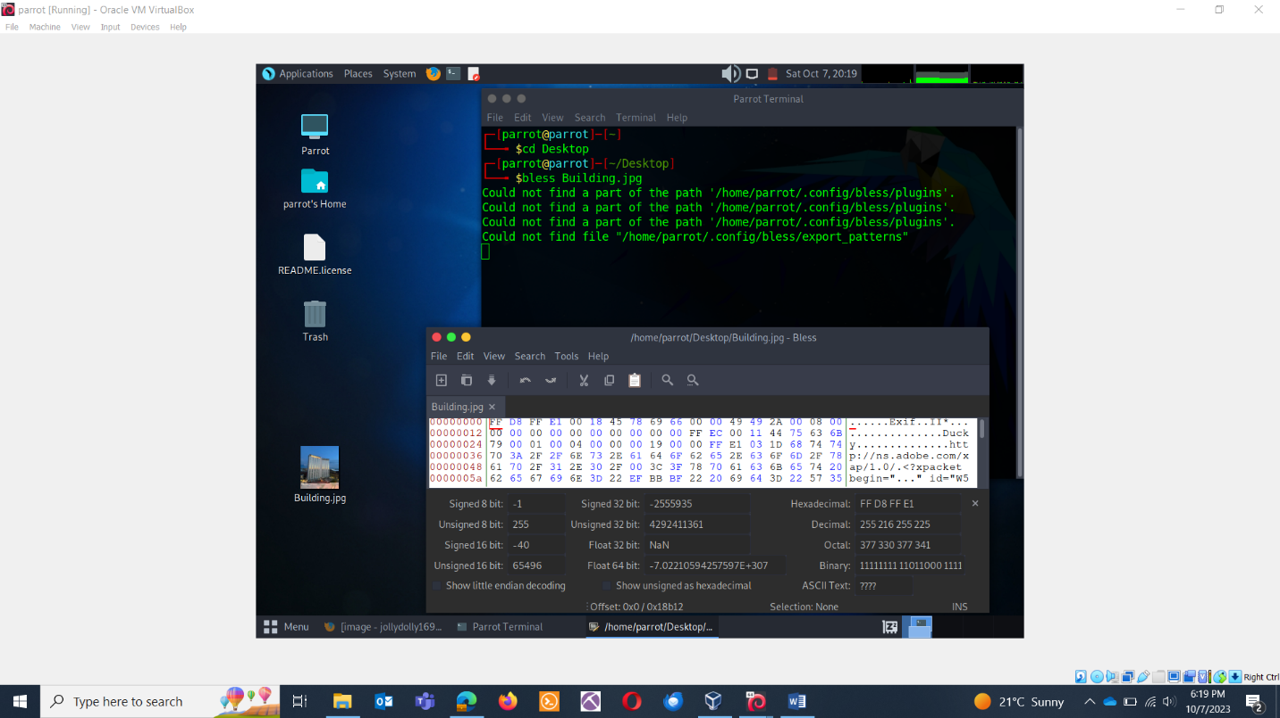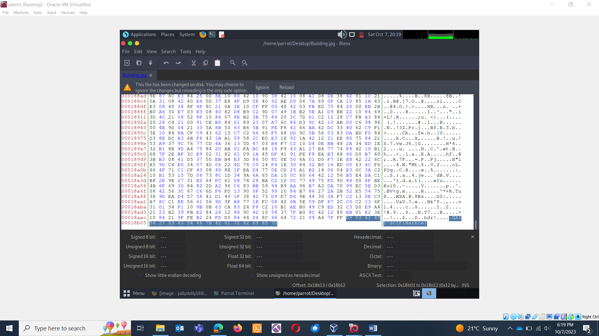

**WANNA ORDER A CAKE: WEBSITE EXPLOITATION**

QUES: Analyze the website to pull out the flag: <http://ec2-18-118-212-137.us-east-2.compute.amazonaws.com/>

ANS: SAIT'SCTF{sheldon}

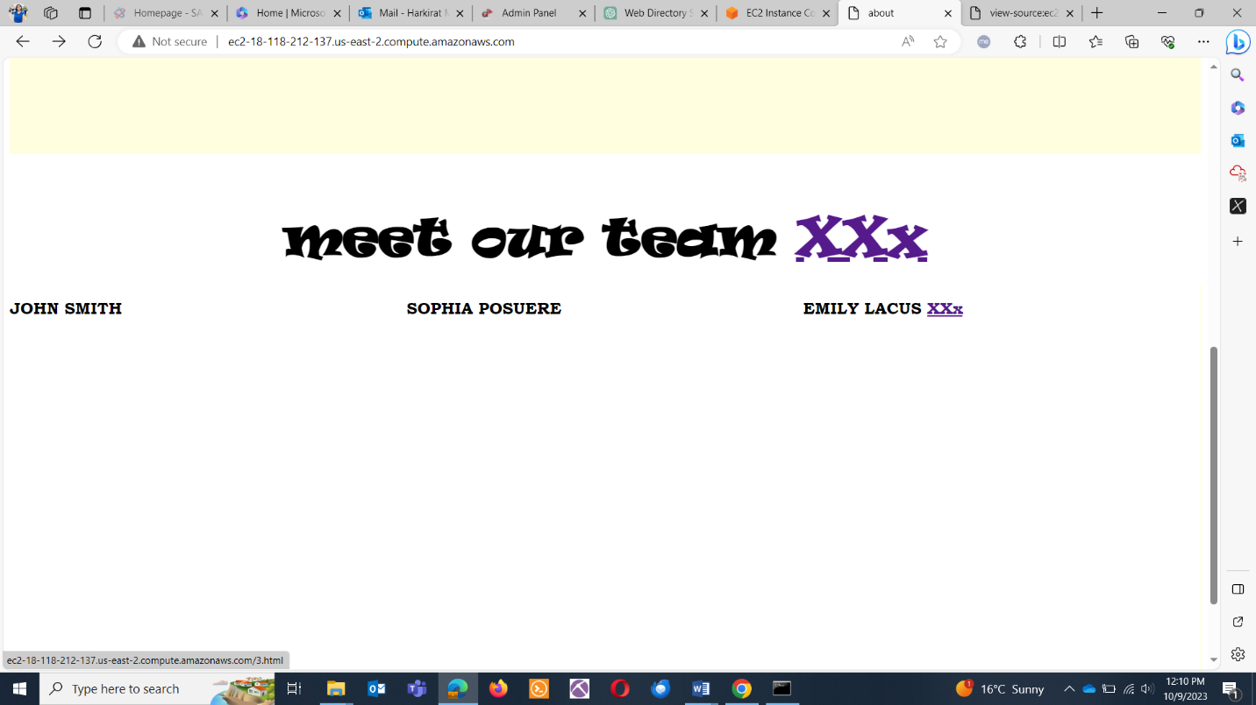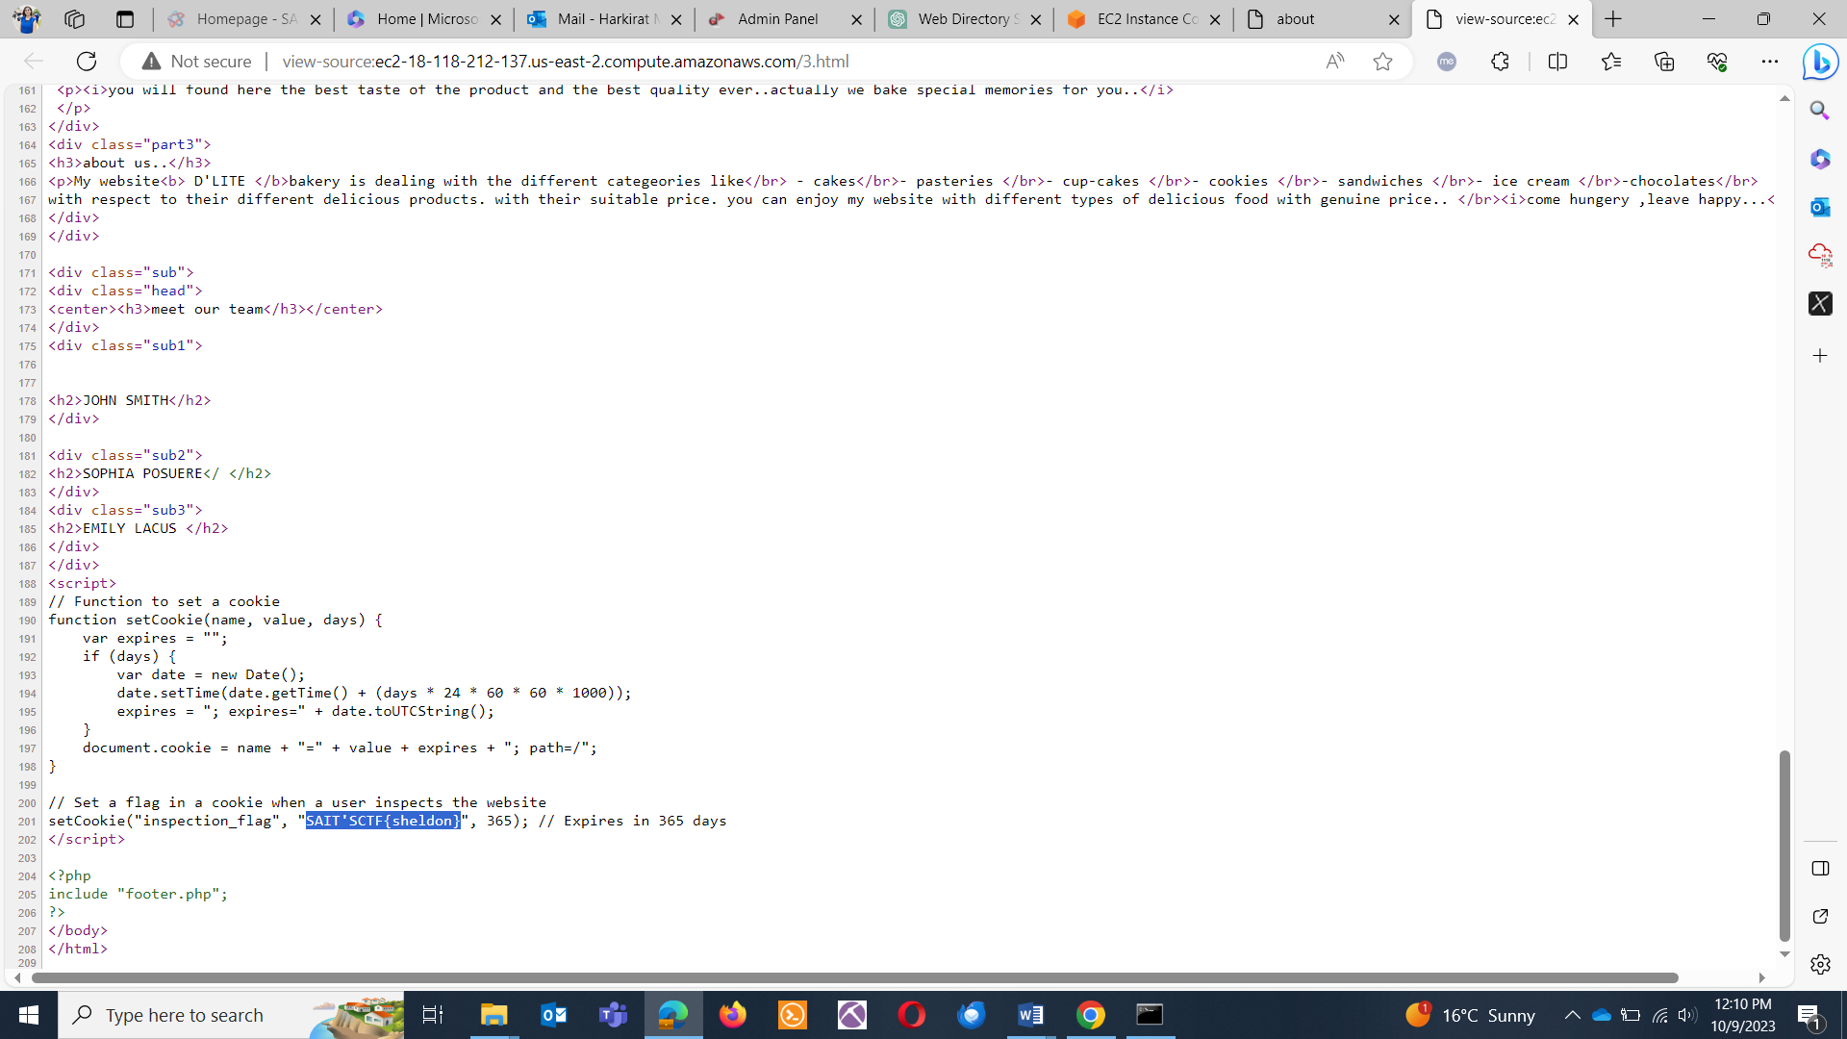

**COUNT THE PAGES: WEBSITE EXPLOITATION**

QUES: Can you hunt for number of php pages in <http://testphp.vulnweb.com>

ANS: SAIT’SCTF{15}

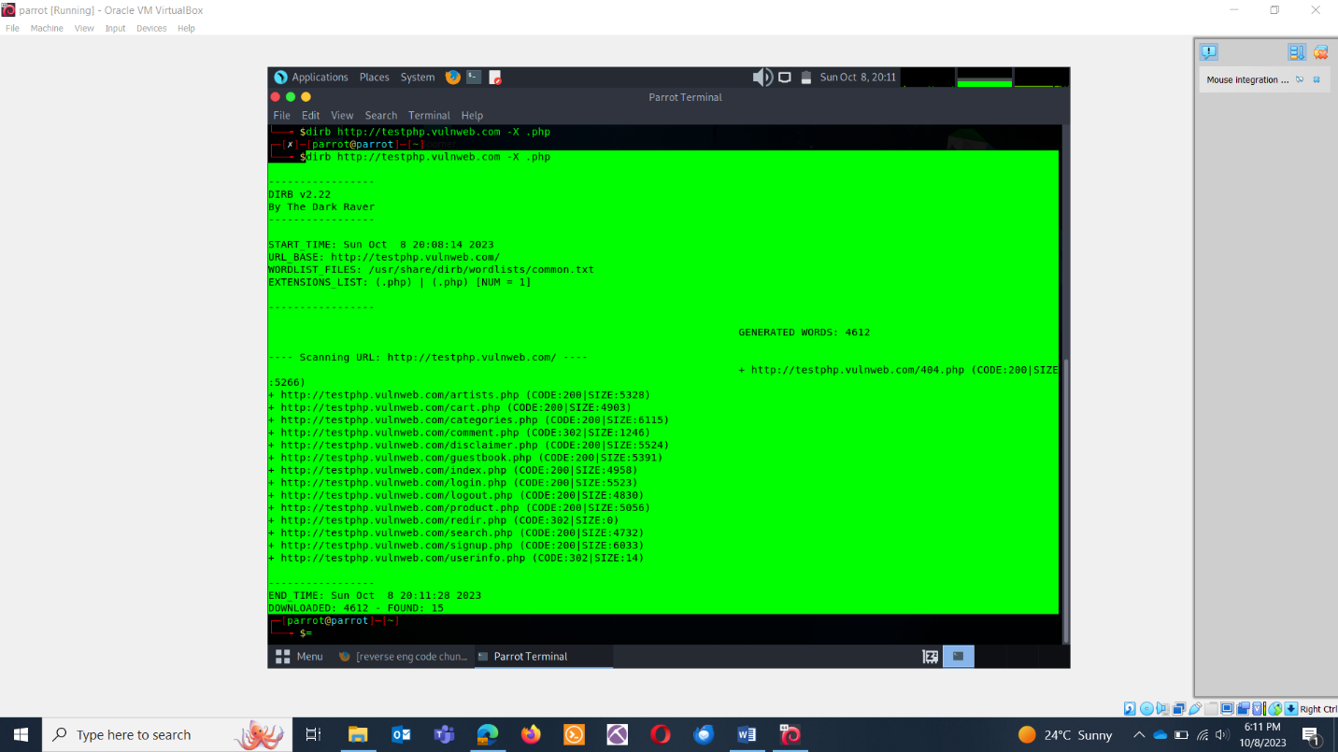

**WE ARE COMPROMISED : DIGITAL FORENSICS**

QUES: Picture this: our system got hit by a mischievous hacker armed with a payload embedded on webserver. Can you decrypt the payload's name ?

ANS: SAIT’SCTF{crack.exe}   
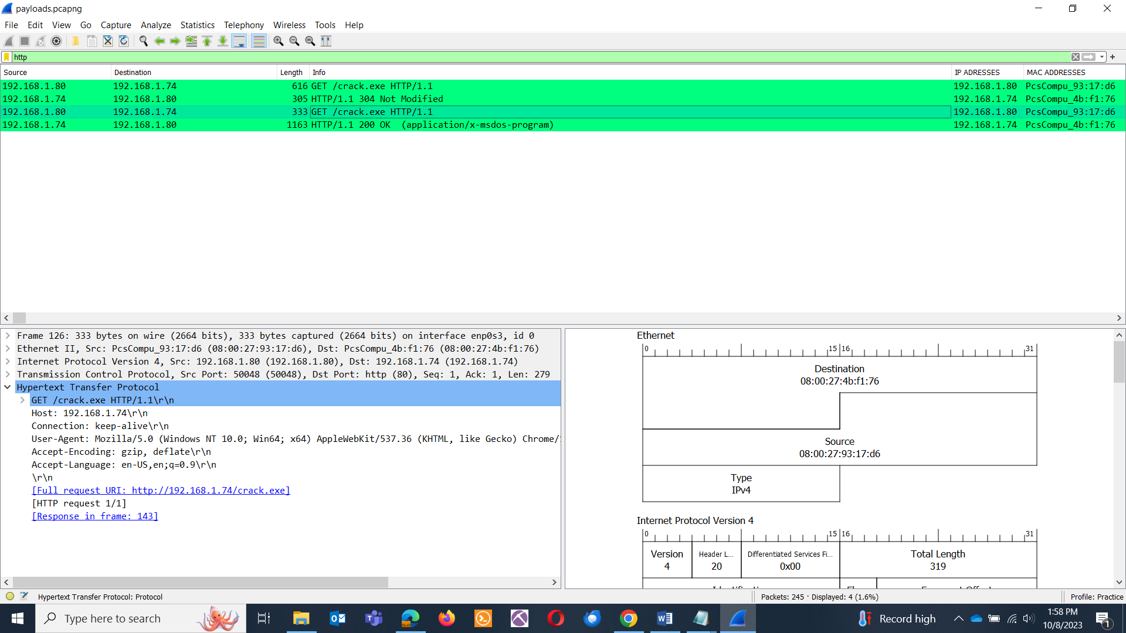

**VAULT DOOR TRAINING: REVERSE ENGINEERING**

QUES: Dr. Evil's Lab - Code Breaker Challenge: Get the Doomsday Blueprint! Dr. Evil's lab is locked down tight! Junior agent got us the code, but it's in VaultDoorTraining.java. Crack the code and unlock the training vault to prove your skills!

ANS: SAIT’SCTF{w4rm1ng_Up_w1tH_jAv4_3808d338b46}

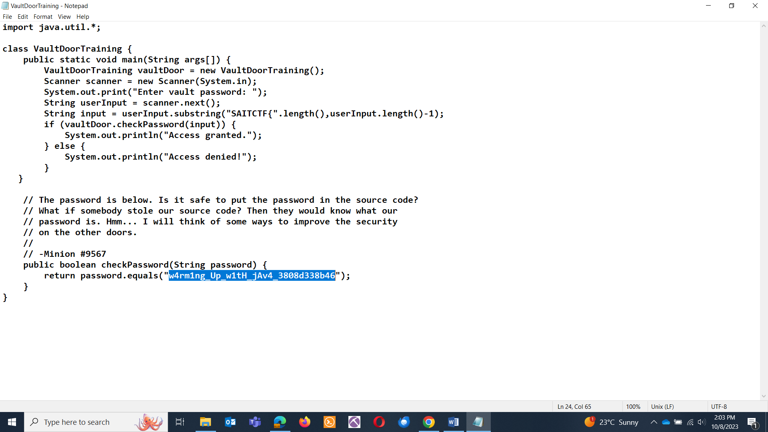

**PEEK INTO A LOG: DIGITAL FORENSICS**

QUES: You are the network admin and recently there was an unlawful entry. The attacker did play with your system. Before you could do anything, the attacker was able to erase their account, but you had the access logs. Pull out the attacker’s name.

ANS: SAIT’SCTF{cinderella}

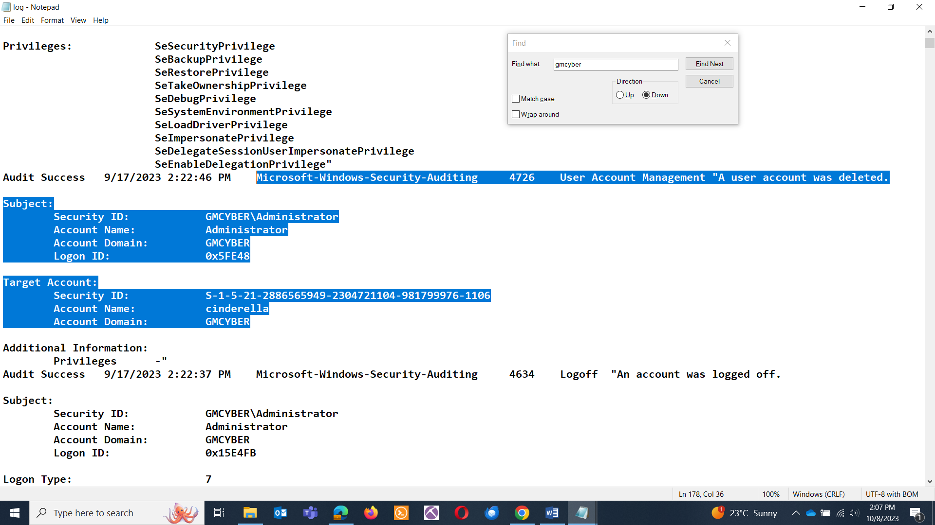

Or

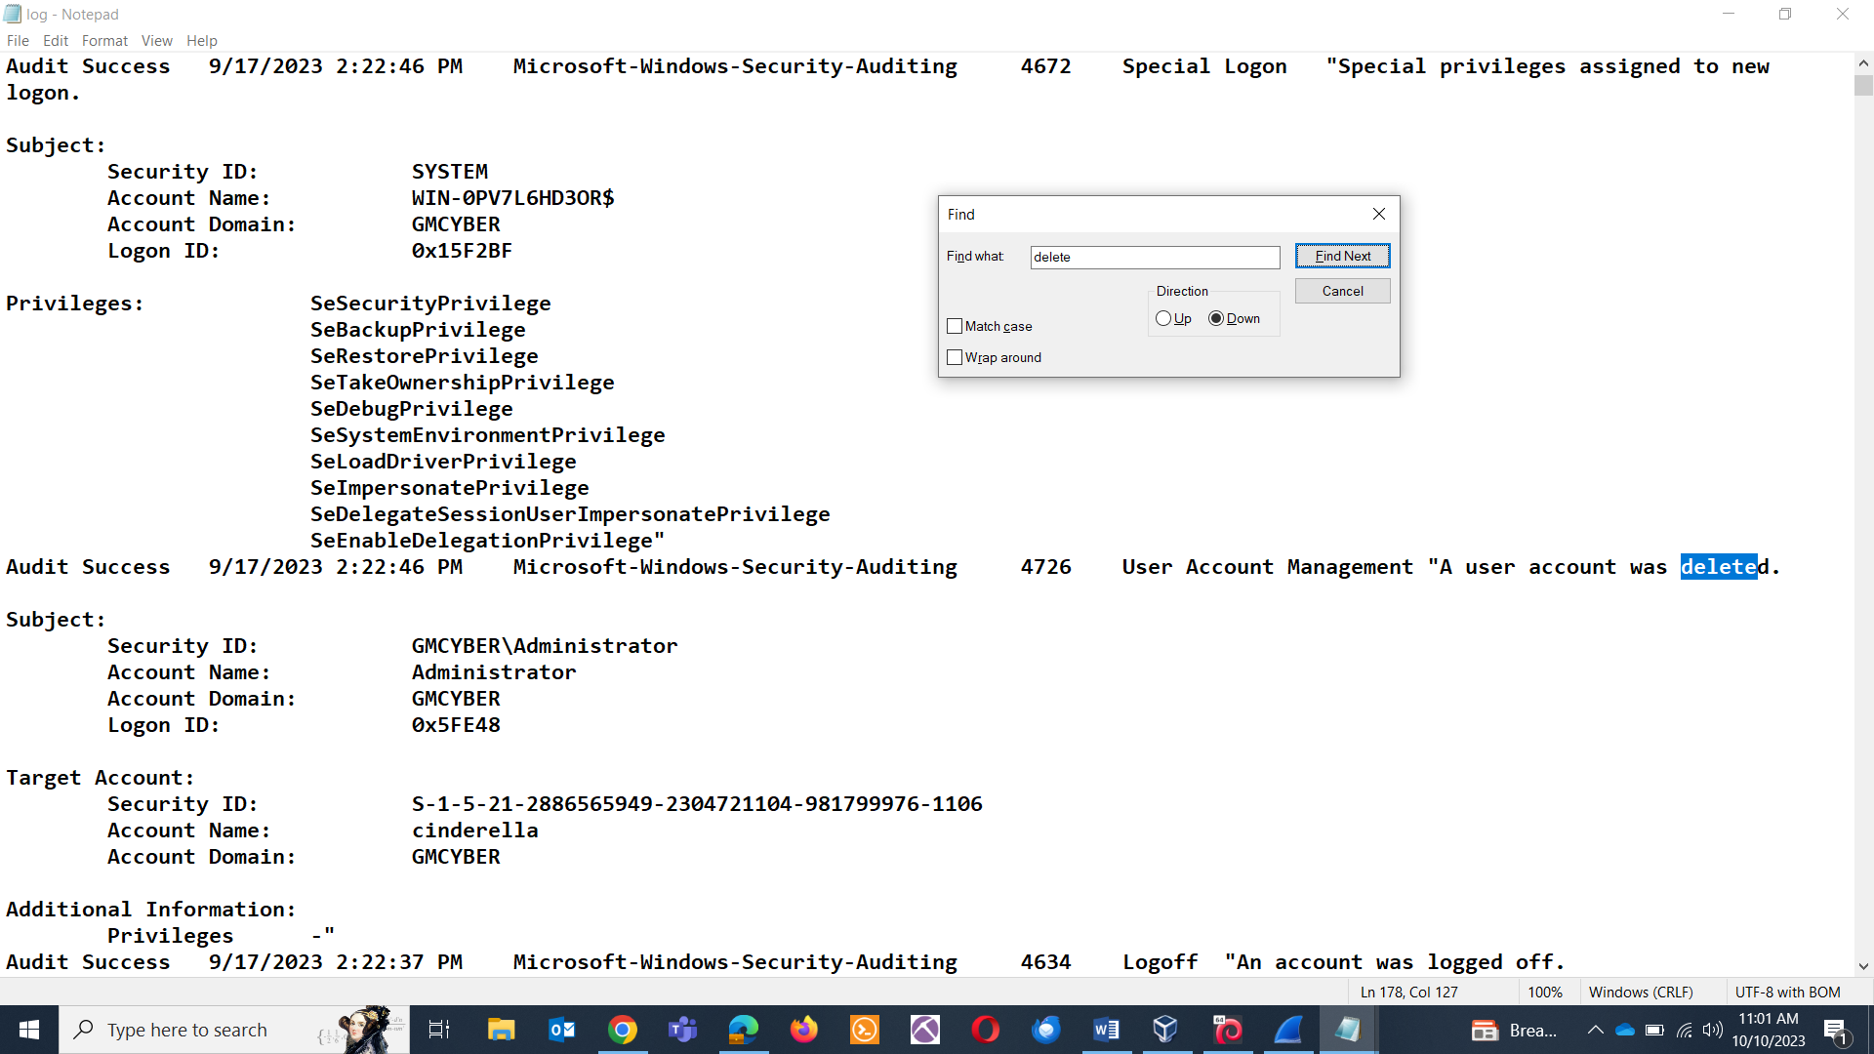

**MCAFEE MADNESS: WHERE IN THE WORLD IS OUR HACKER: GENERAL**

QUES: Together we are powerful! 🌐 McAfee alert!! Get 60% discount. An attacker is pulling a fast one by sending you an email about enhancing your security. Can you uncover the country name where this cheeky hacker is sipping cyber-tea and plotting their next move?

ANS: SAIT’SCTF{UKRAINE}

EMAIL HEADER ANALYSIS

* Opening the email.

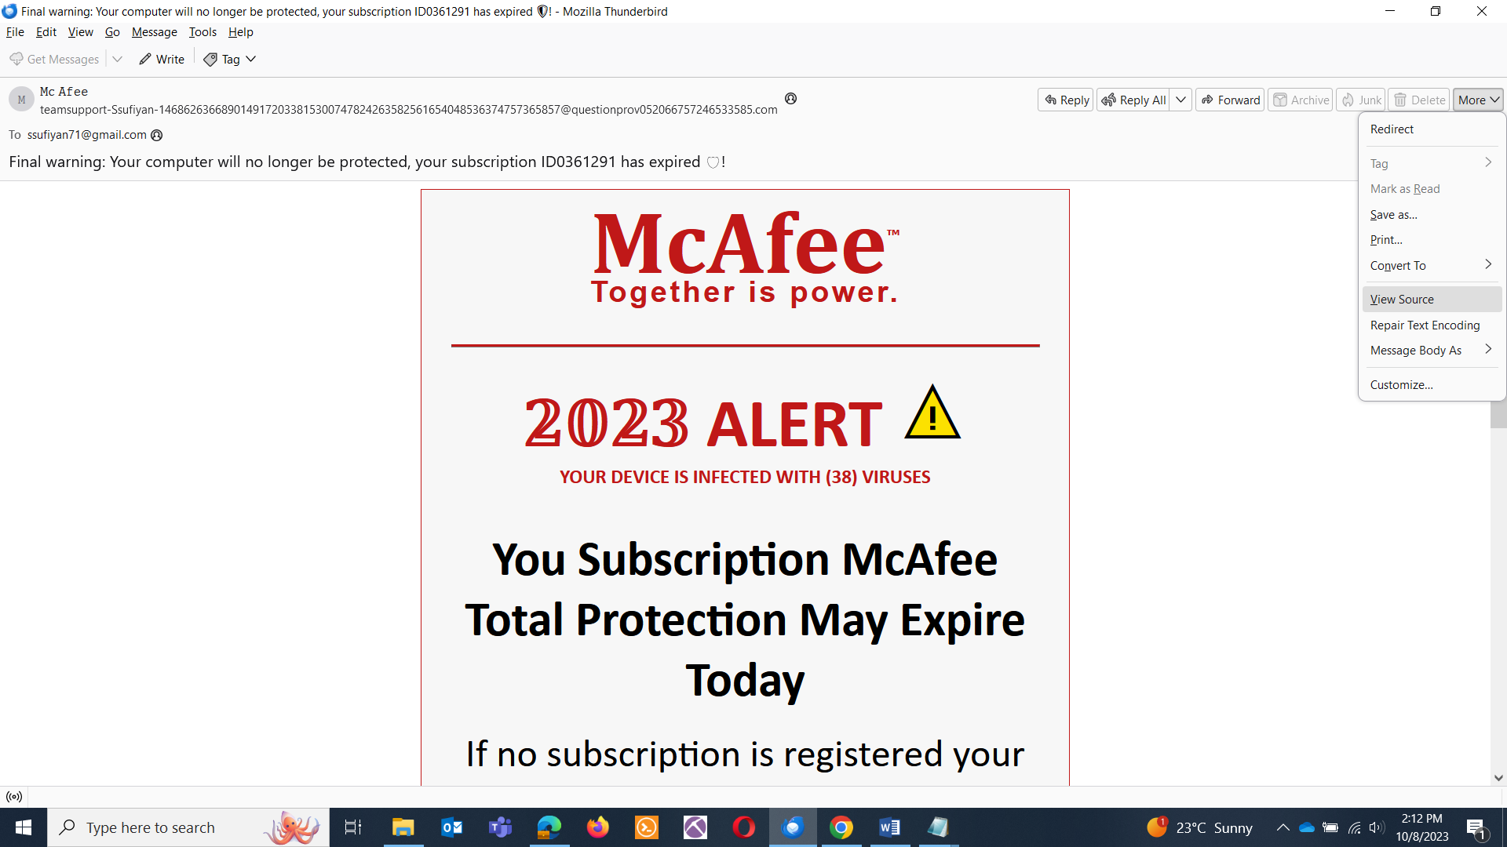

* Viewing the source and copying everything.

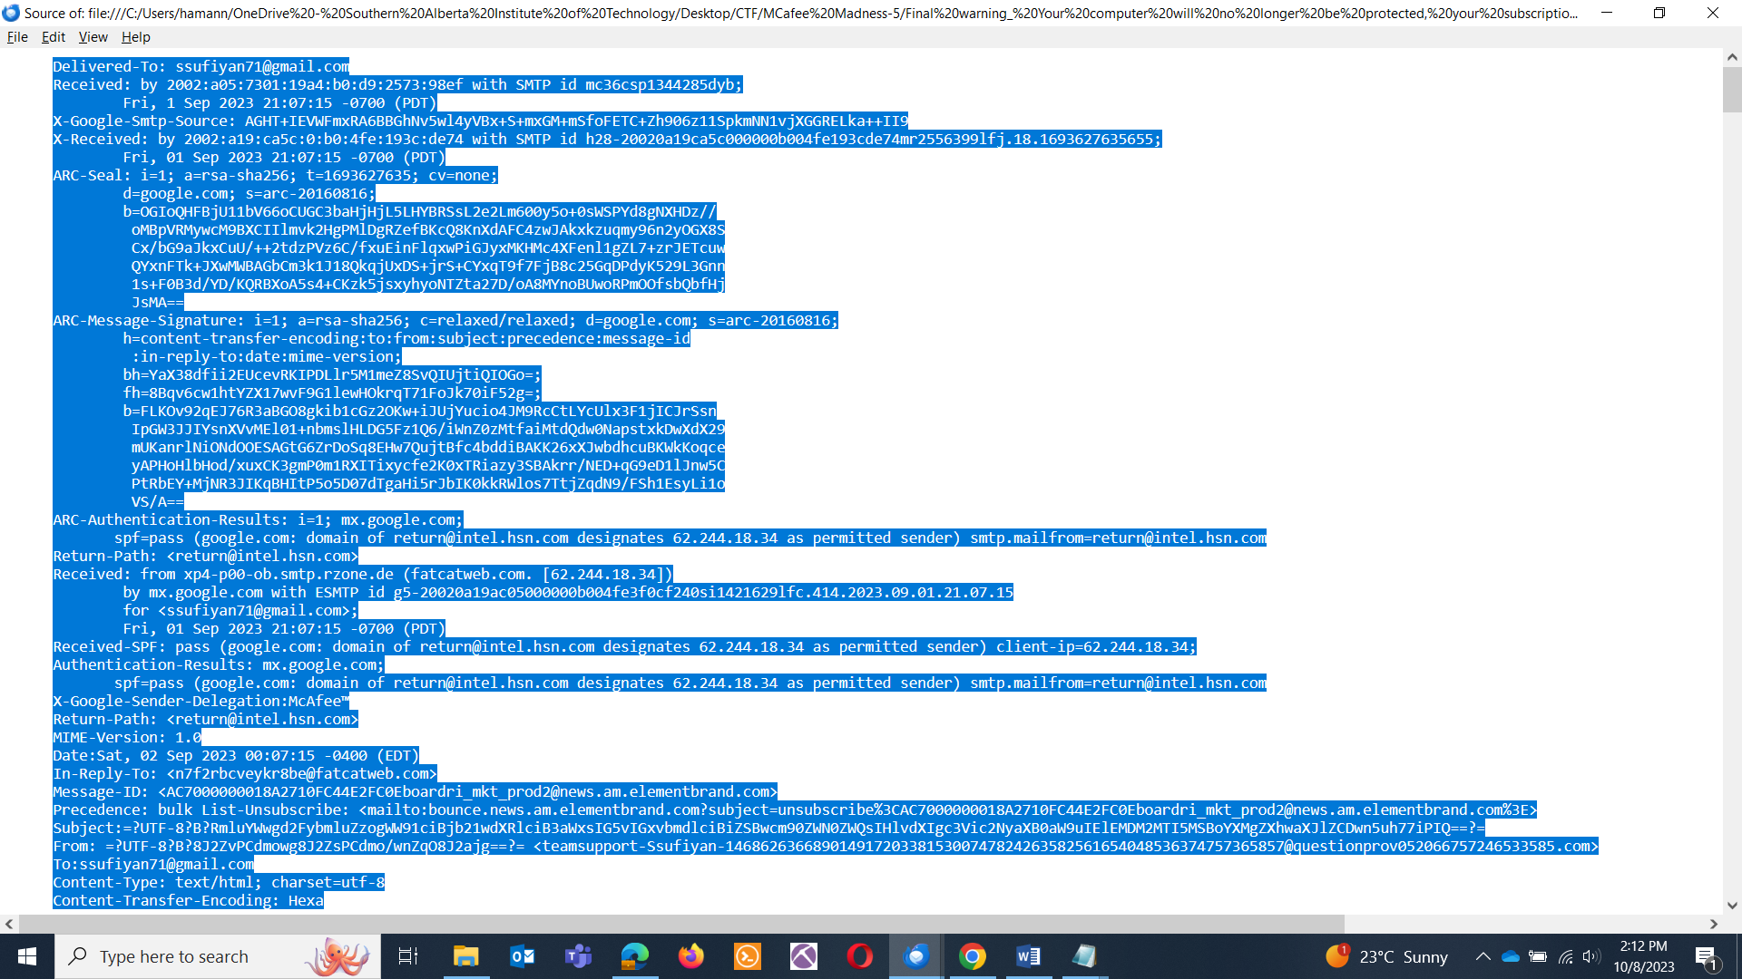

* Using MXTXT lookup to analyze the email: 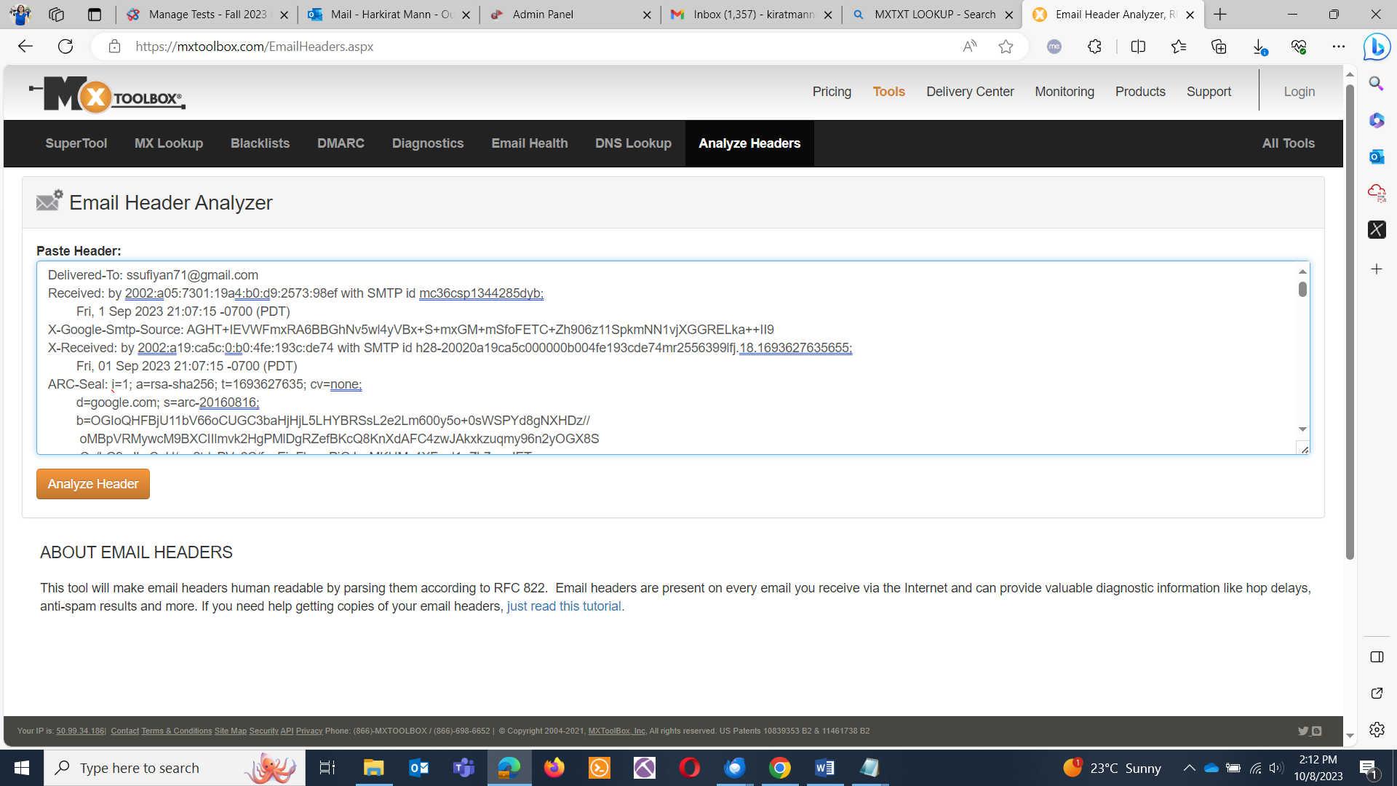
* Click on analyze and in relay information you’ll see the ip address in first hops.

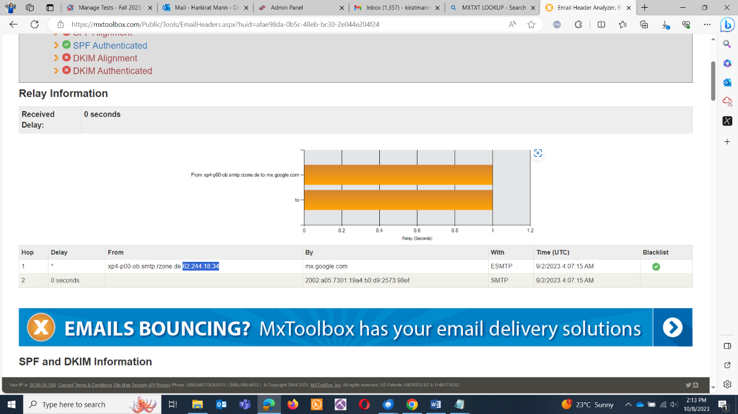

* Pasting the IP in iplookup

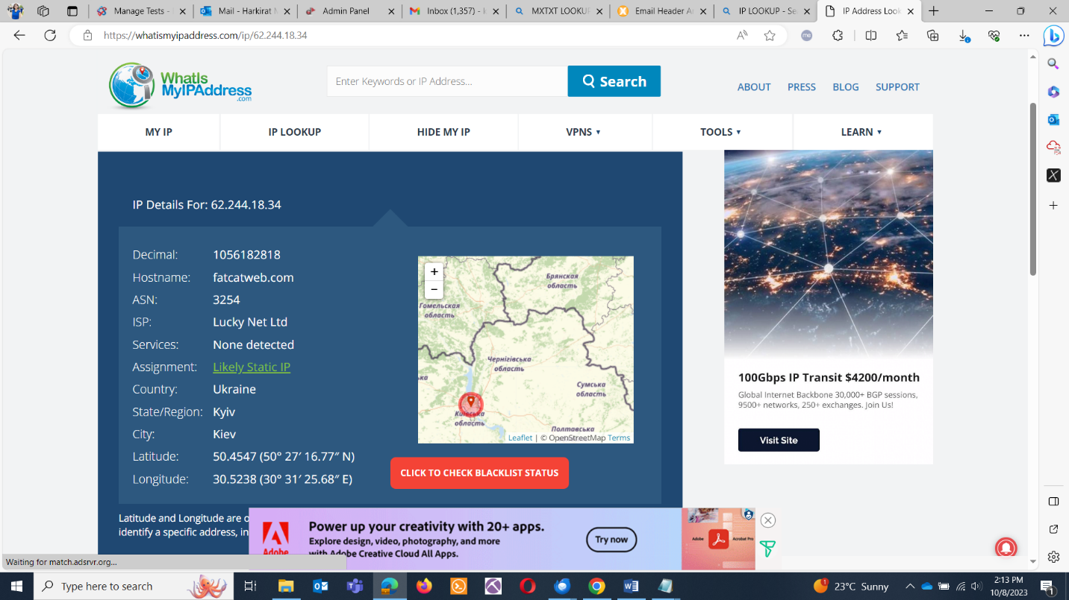

**LONG RAMBLING DIRECTORY : GENERAL**

QUES: Long rambling directory? Can you loop directories inside a directory? Find the flag if you can?

ANS:SAIT'SCTF{123456789}

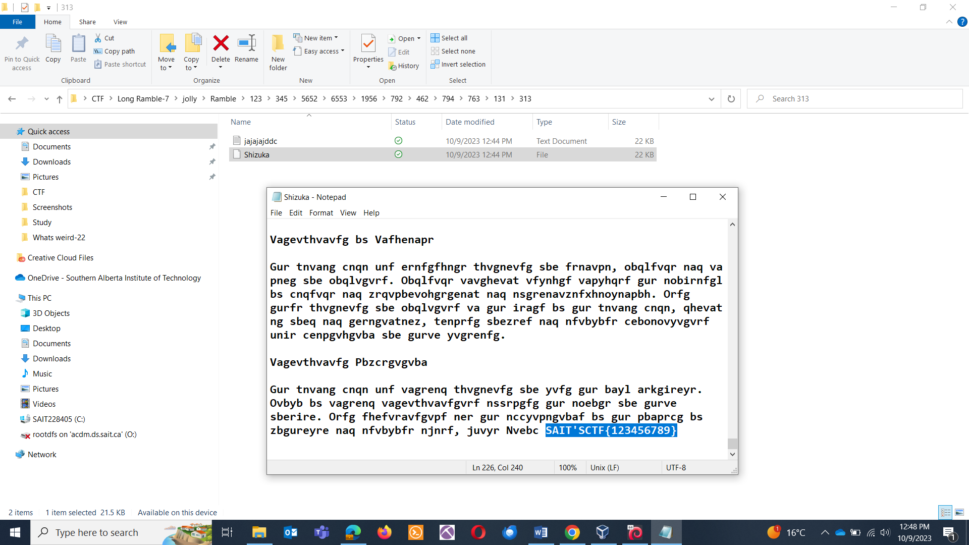

**HERITAGE HALL**

QUES: Find the flag in the image.

ANS: SAIT’SCTF{YouareoneofthebeststudenthereatSAIT}

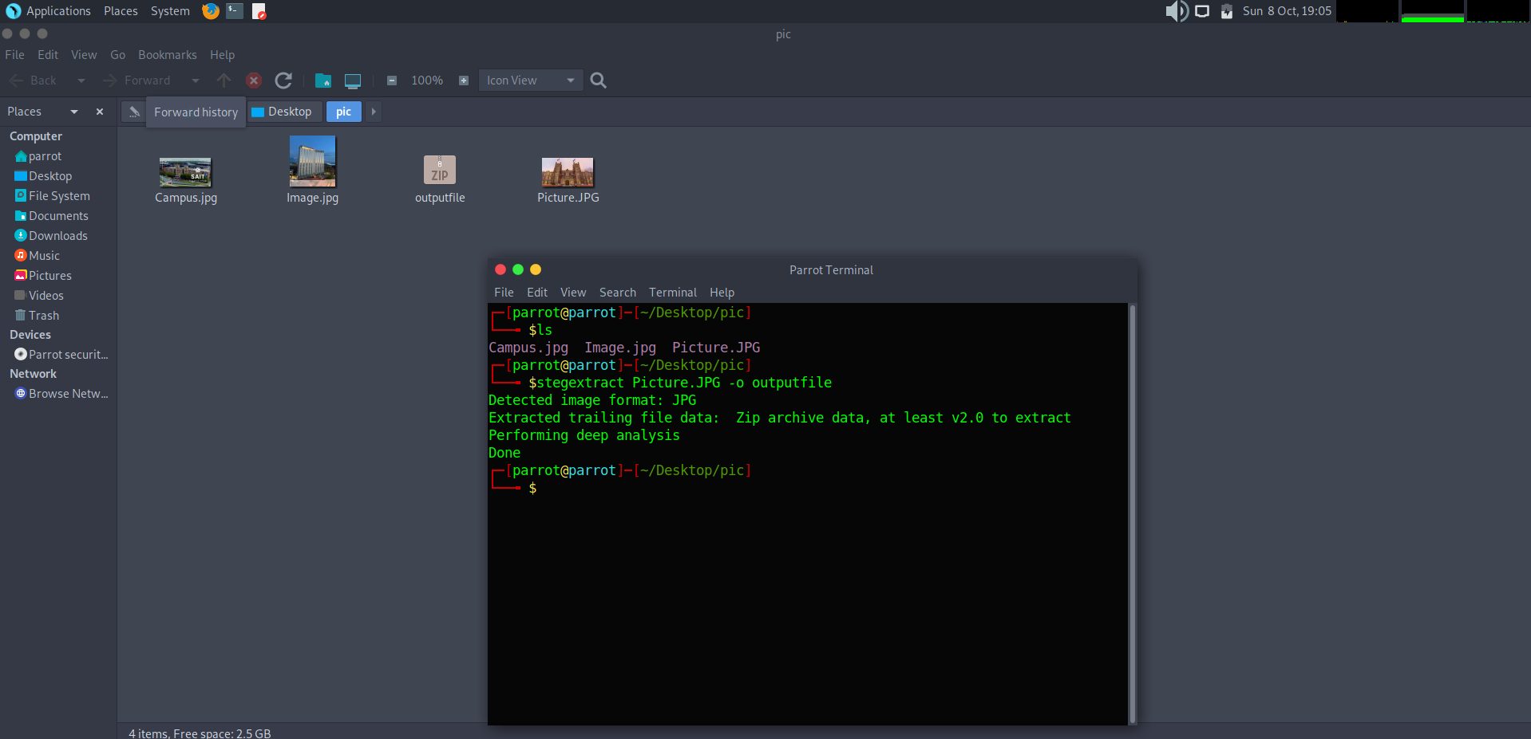

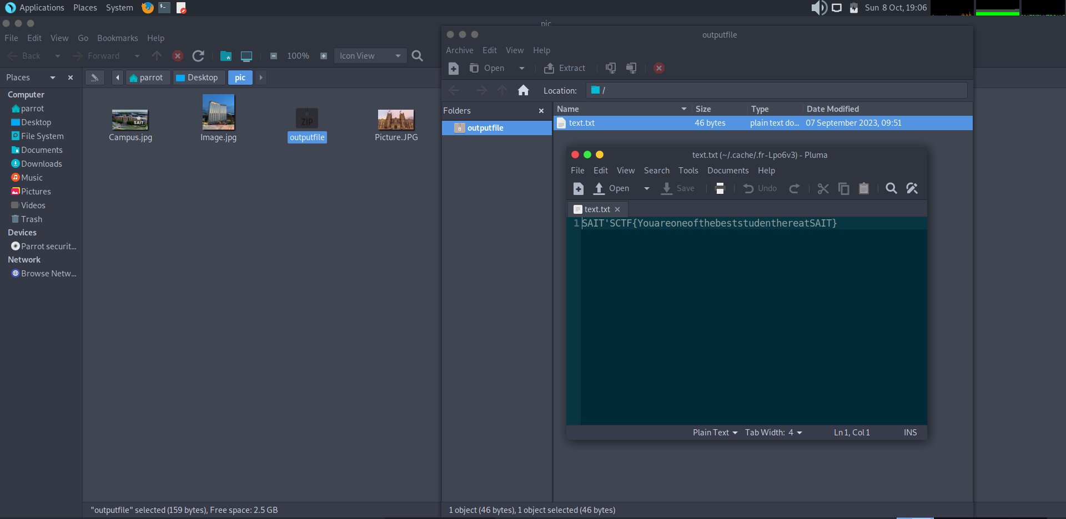

**31TOR: CRYPTOGRAPHY**

QUES: Do you know what ROT13 is ? Crypto is necessary.

FNVGPGS{Npgvbavfgursbhaqngvbanyxrlgbnyyfhpprff}

ANS: SAITCTF{Actionisthefoundationalkeytoallsuccess}

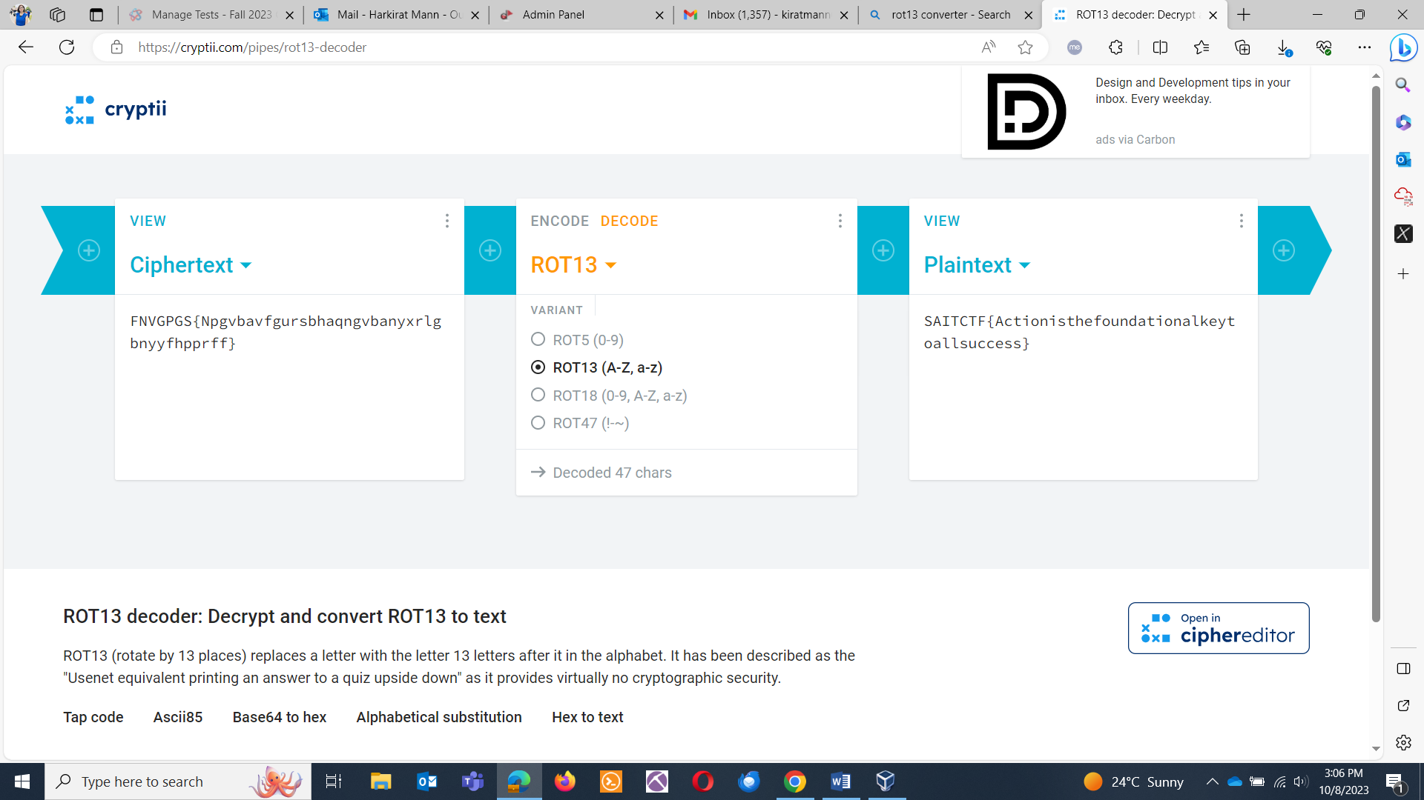

**WACKY DATABASE ADVENTURE: WEBSITE EXPLOITATION**

QUES: You've just been granted access to a super-secret database, but here's the catch—every 5th and 10th entry in all the tables of the database is as strange as a penguin in a tutu! Pull a flag out.

ANS: SAIT’SCTF{rockymountains}

SOLUTION: Database is Sqlite3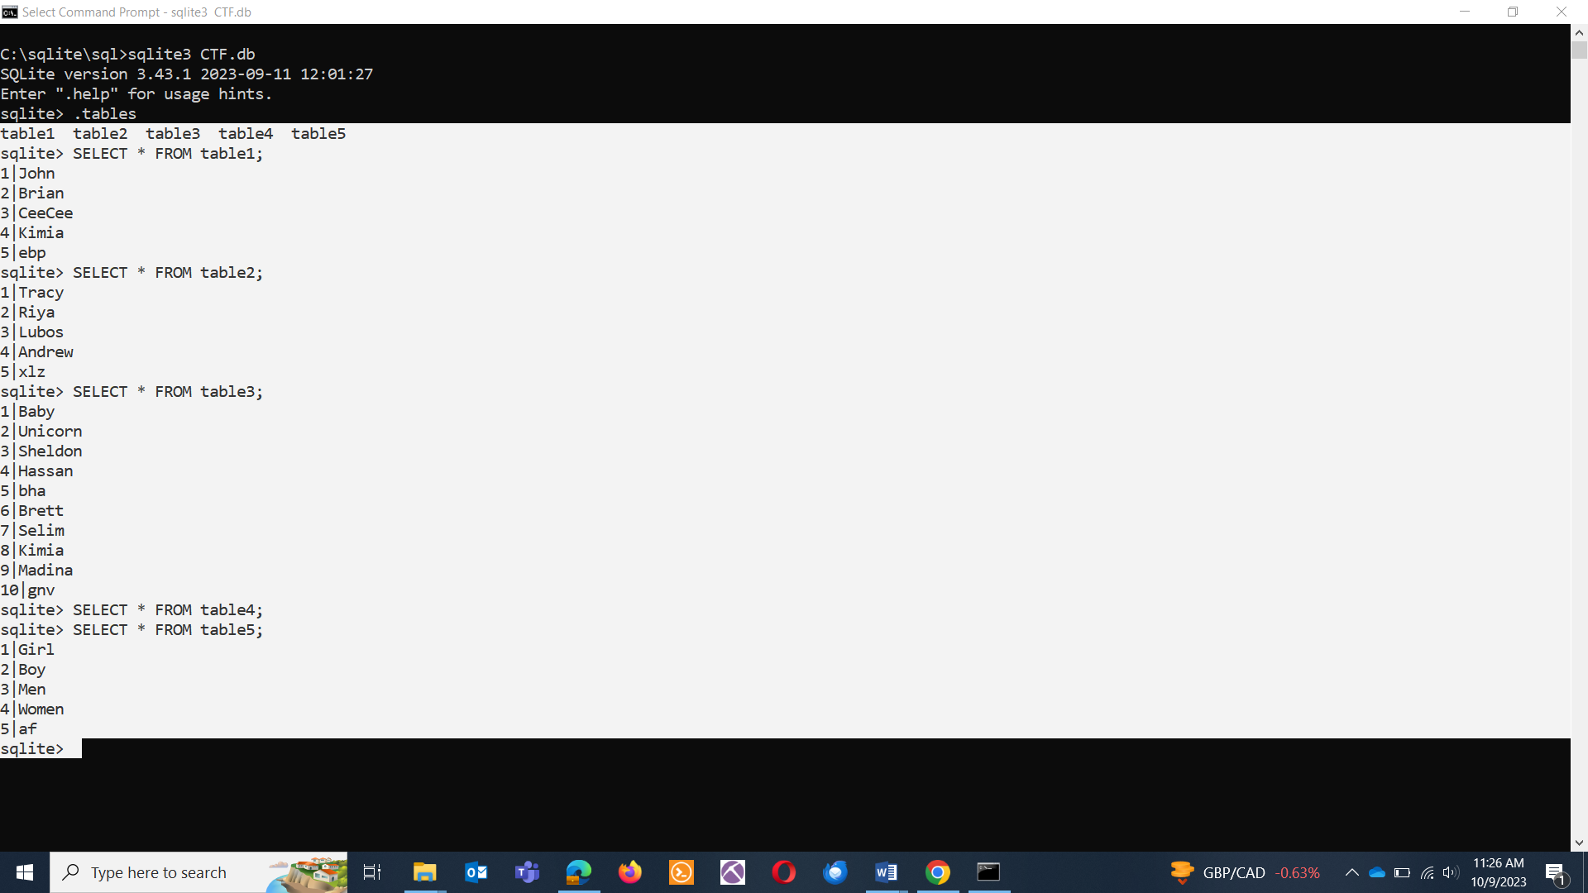

Combining 5th and 10th entries in each table: ebpxlzbhagnvaf

ROT13 decoding:

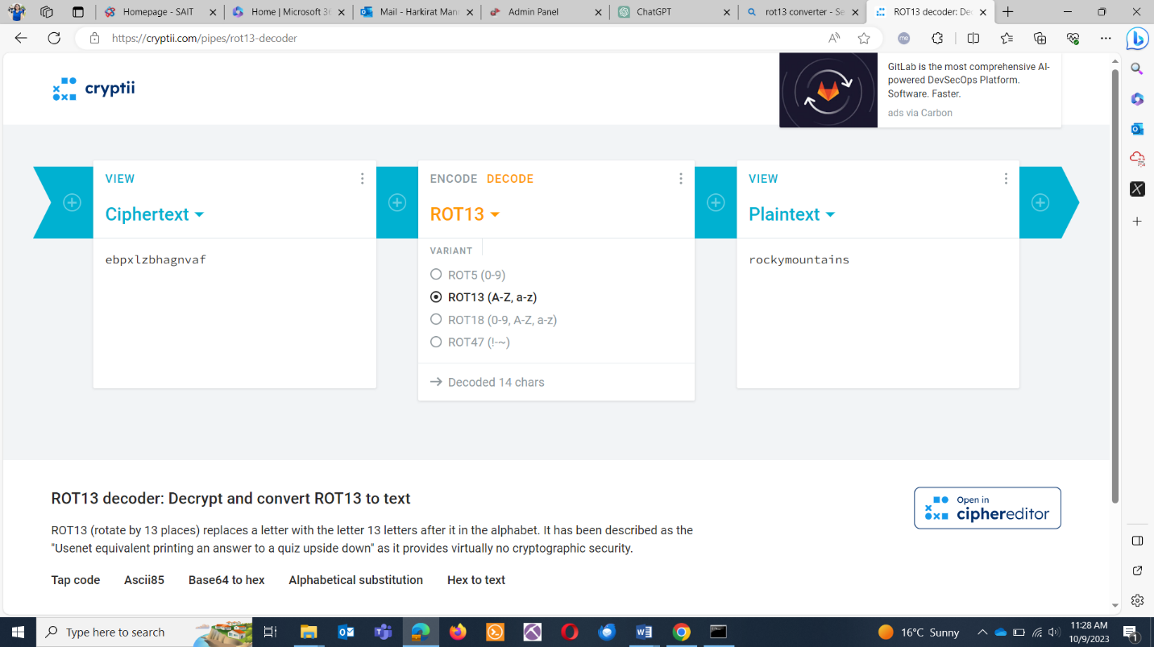

**SAIT’S CAMPUS: DIGITAL FORENSICS**

QUES: Find the flag.

ANS: SAIT’SCTF{Snowiscoming}

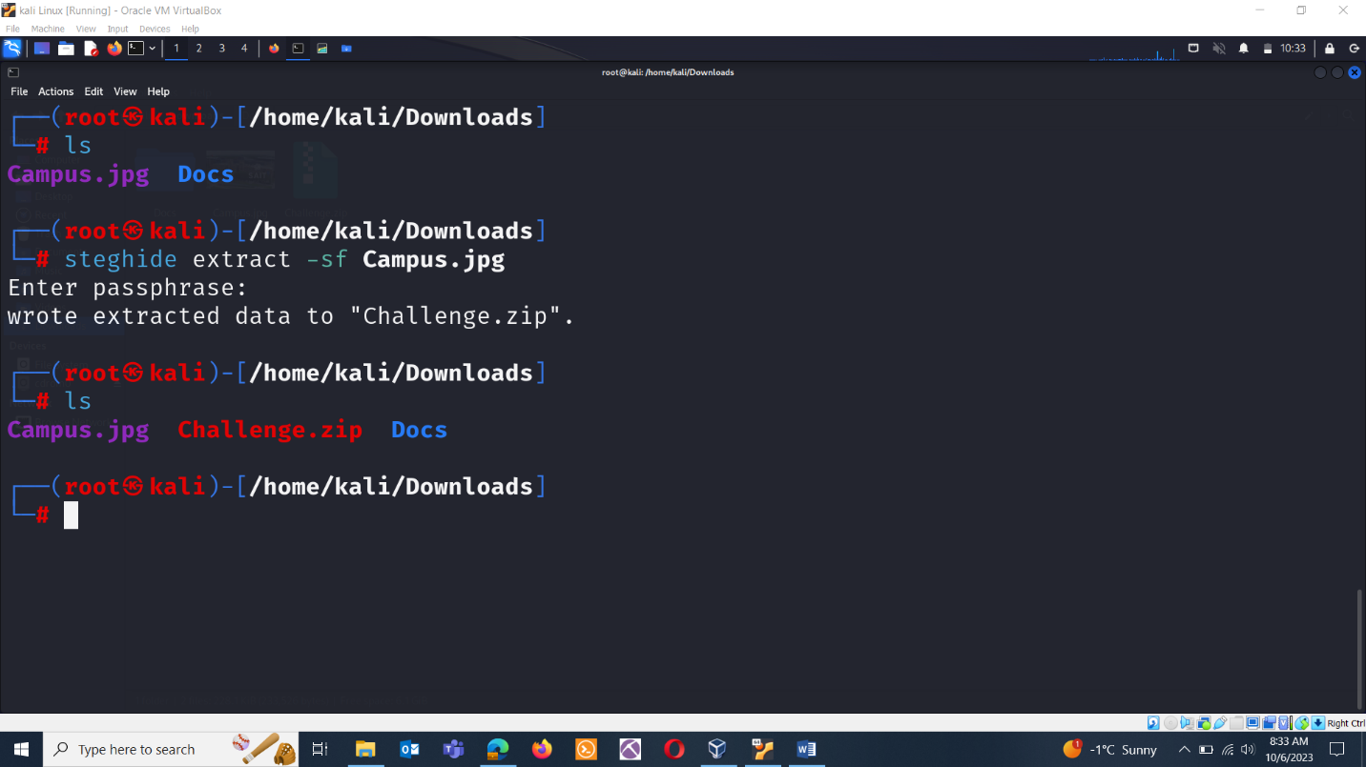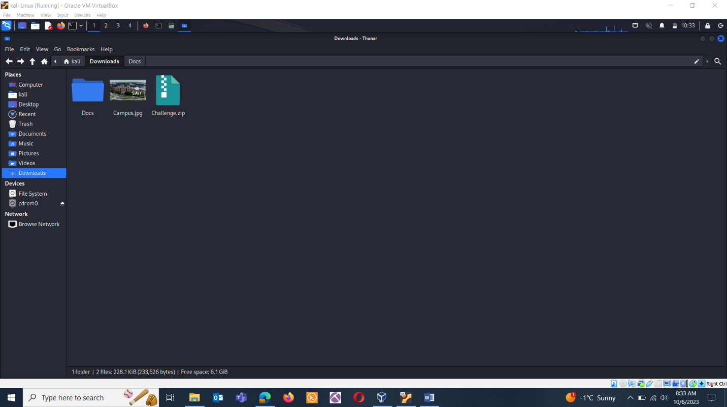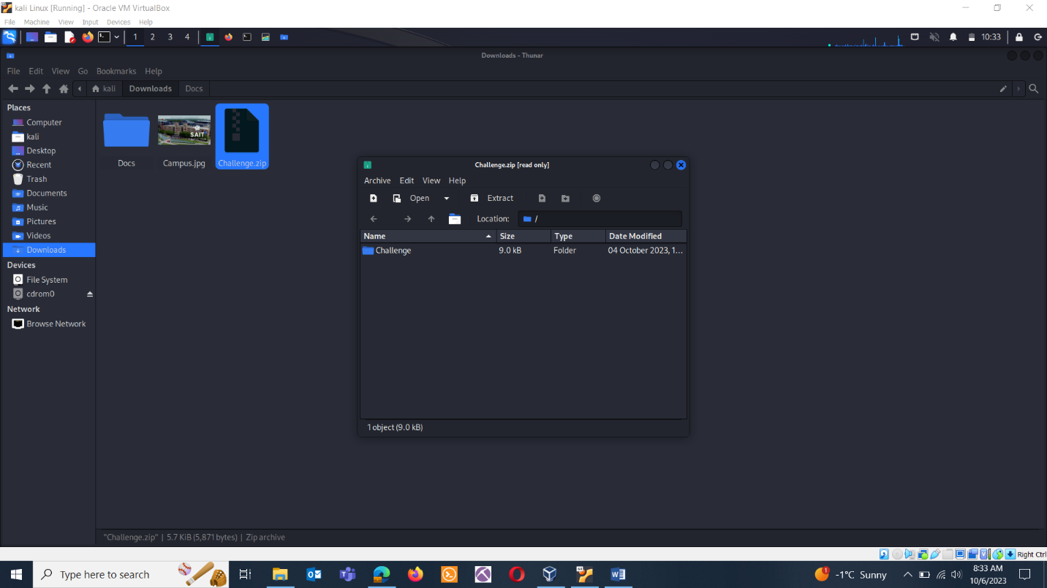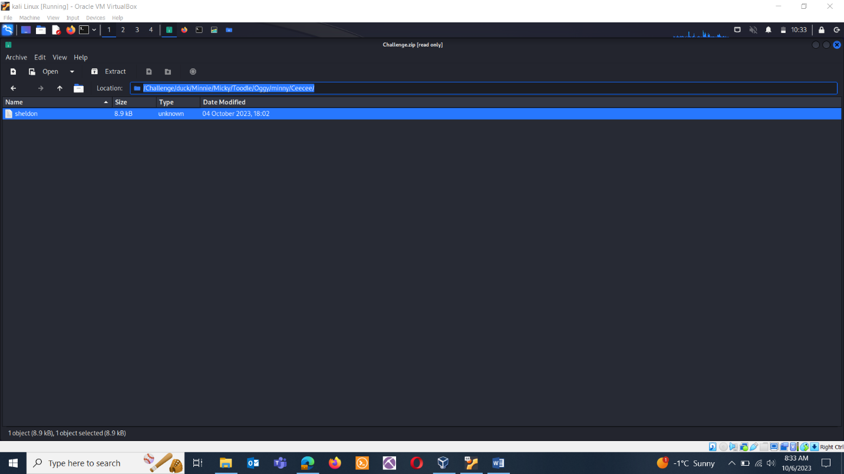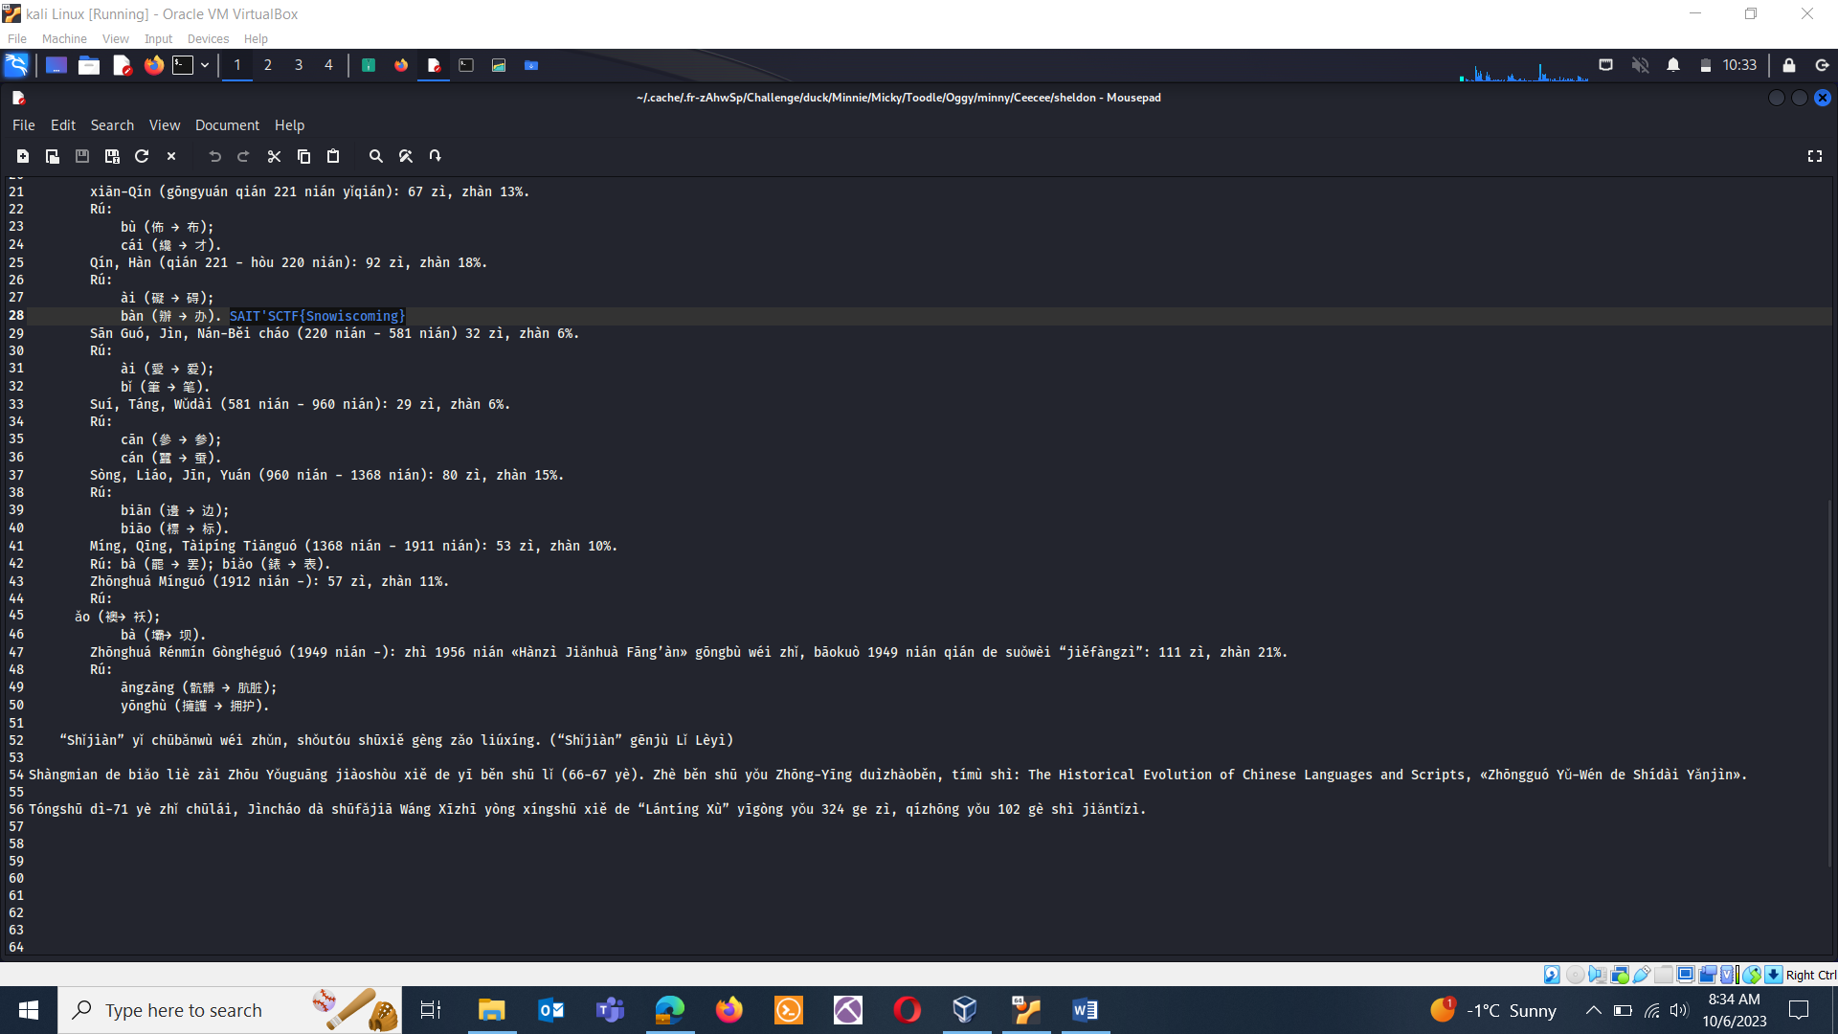

**CAGHZYYELAKUY : CRYPTOGRAPHY**

QUES: The one time pad can be cryptographically secure, but not when you know the key. Can you solve this? We've given you the encrypted flag, key, and a table to help CAGHZYYELAKUY with the key of AAFZBTABACKU. Can you use this table to solve it?

ANS: SAIT’SCTF{CALGARYFLAMES}

SOLUTION: Matching the words manually in the table.

C & A = C

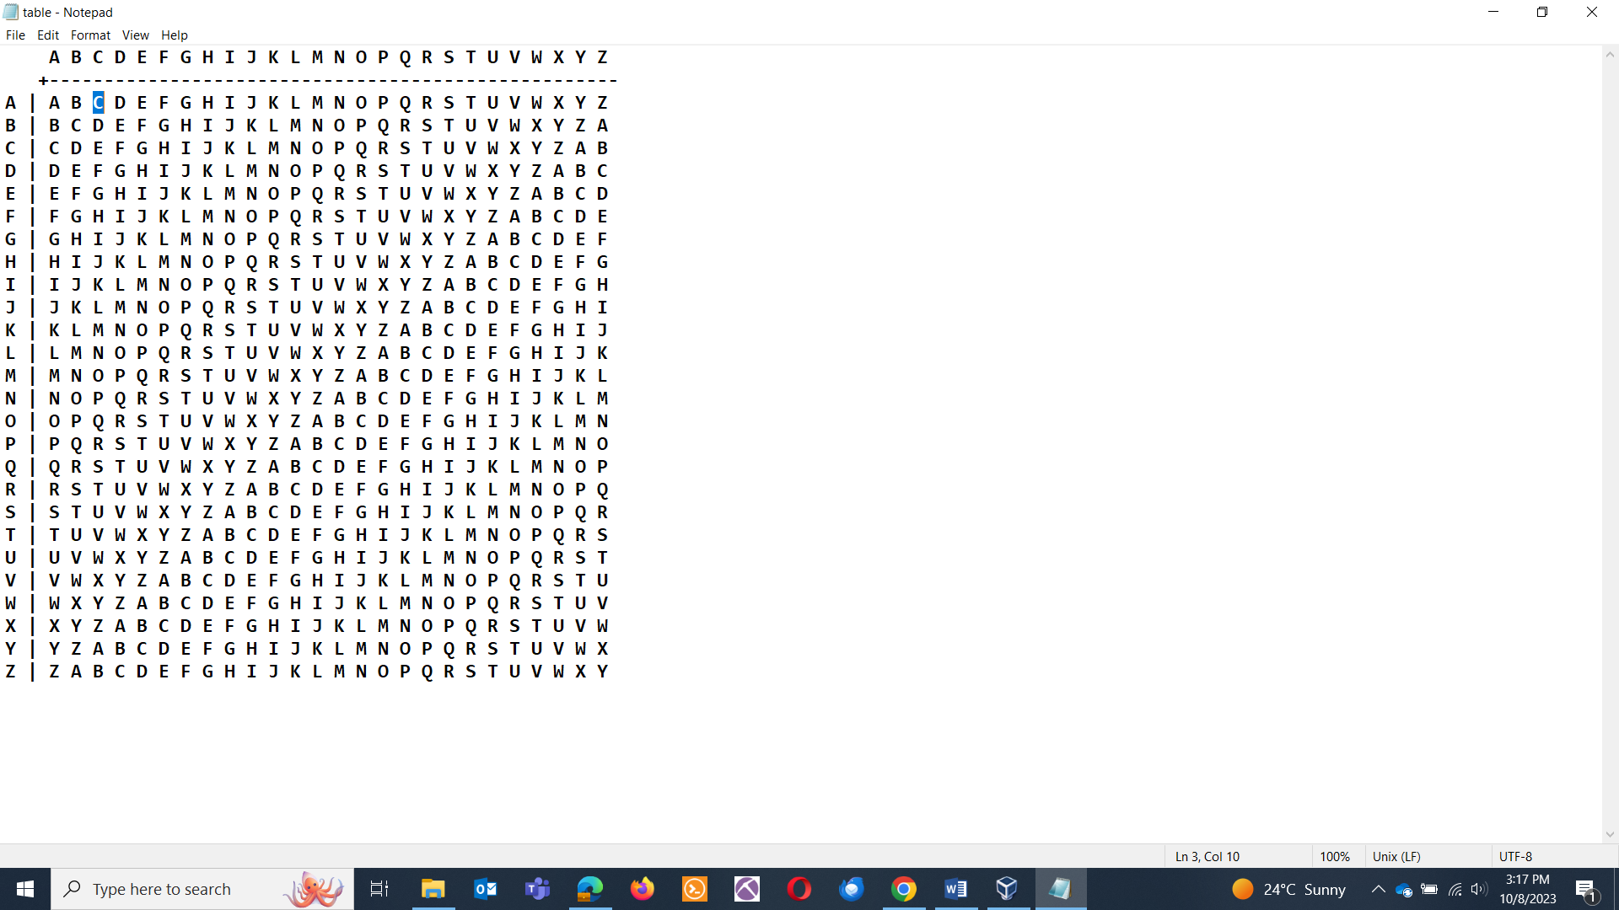

A & A = A

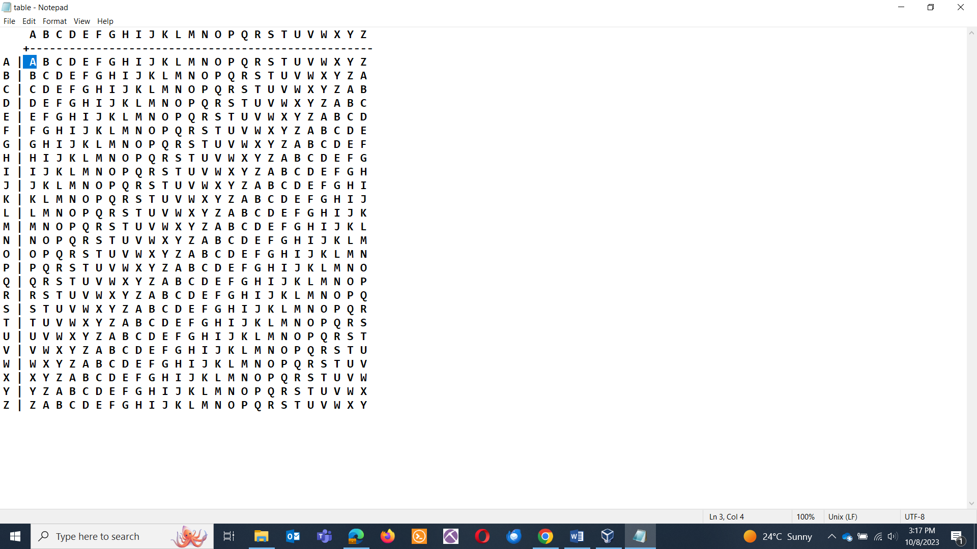

G & F =

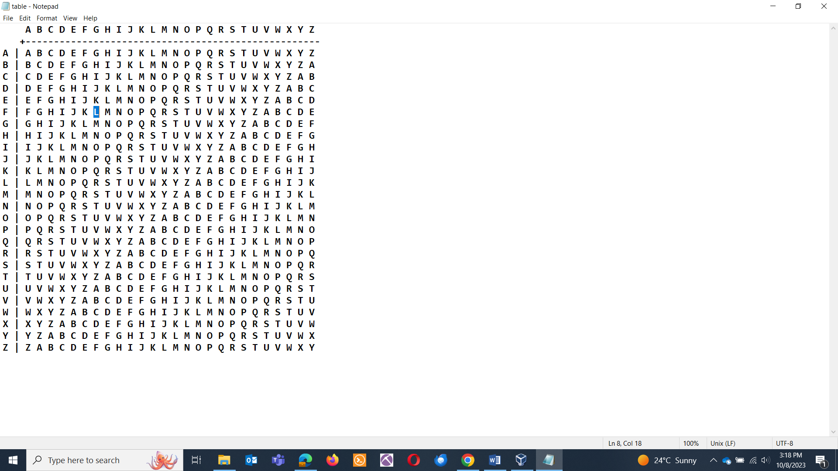

**CRACKER! CRACKER! REVERSE ENGINEERING**

Here is a cracker. Blast it to get a flag.

ANS: SAIT’SCTF{You_Found_it}

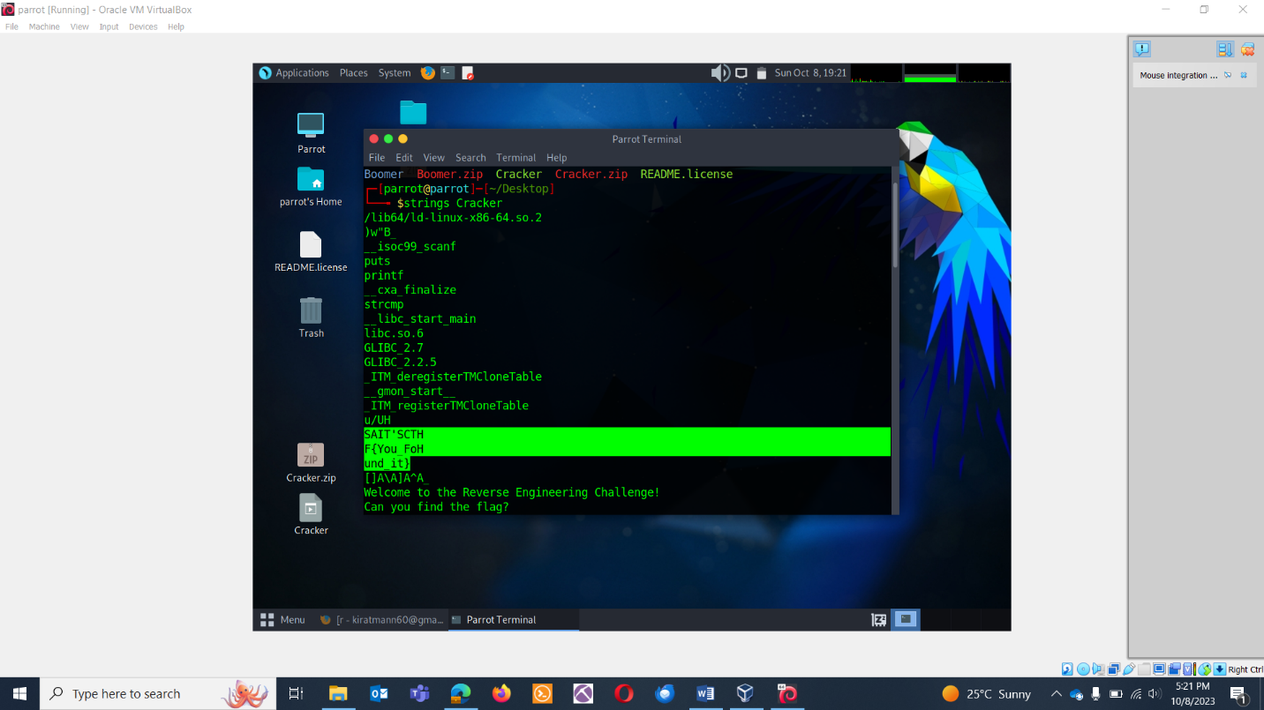

**SECRET CODE: CRYPTOGRAPHY**

QUES: A Top-secret file encoded As U0FJVCdTQ1RGe2l0Z2V0c2hhcmRlcmZyb21oZXJlfQ==.

There's an equal sign (=) at the end. Is it just for show, or does it hold the key to unlock the mystery? Can you figure out what's so special about that equal sign?

ANS: SAIT'SCTF{itgetsharderfromhere} 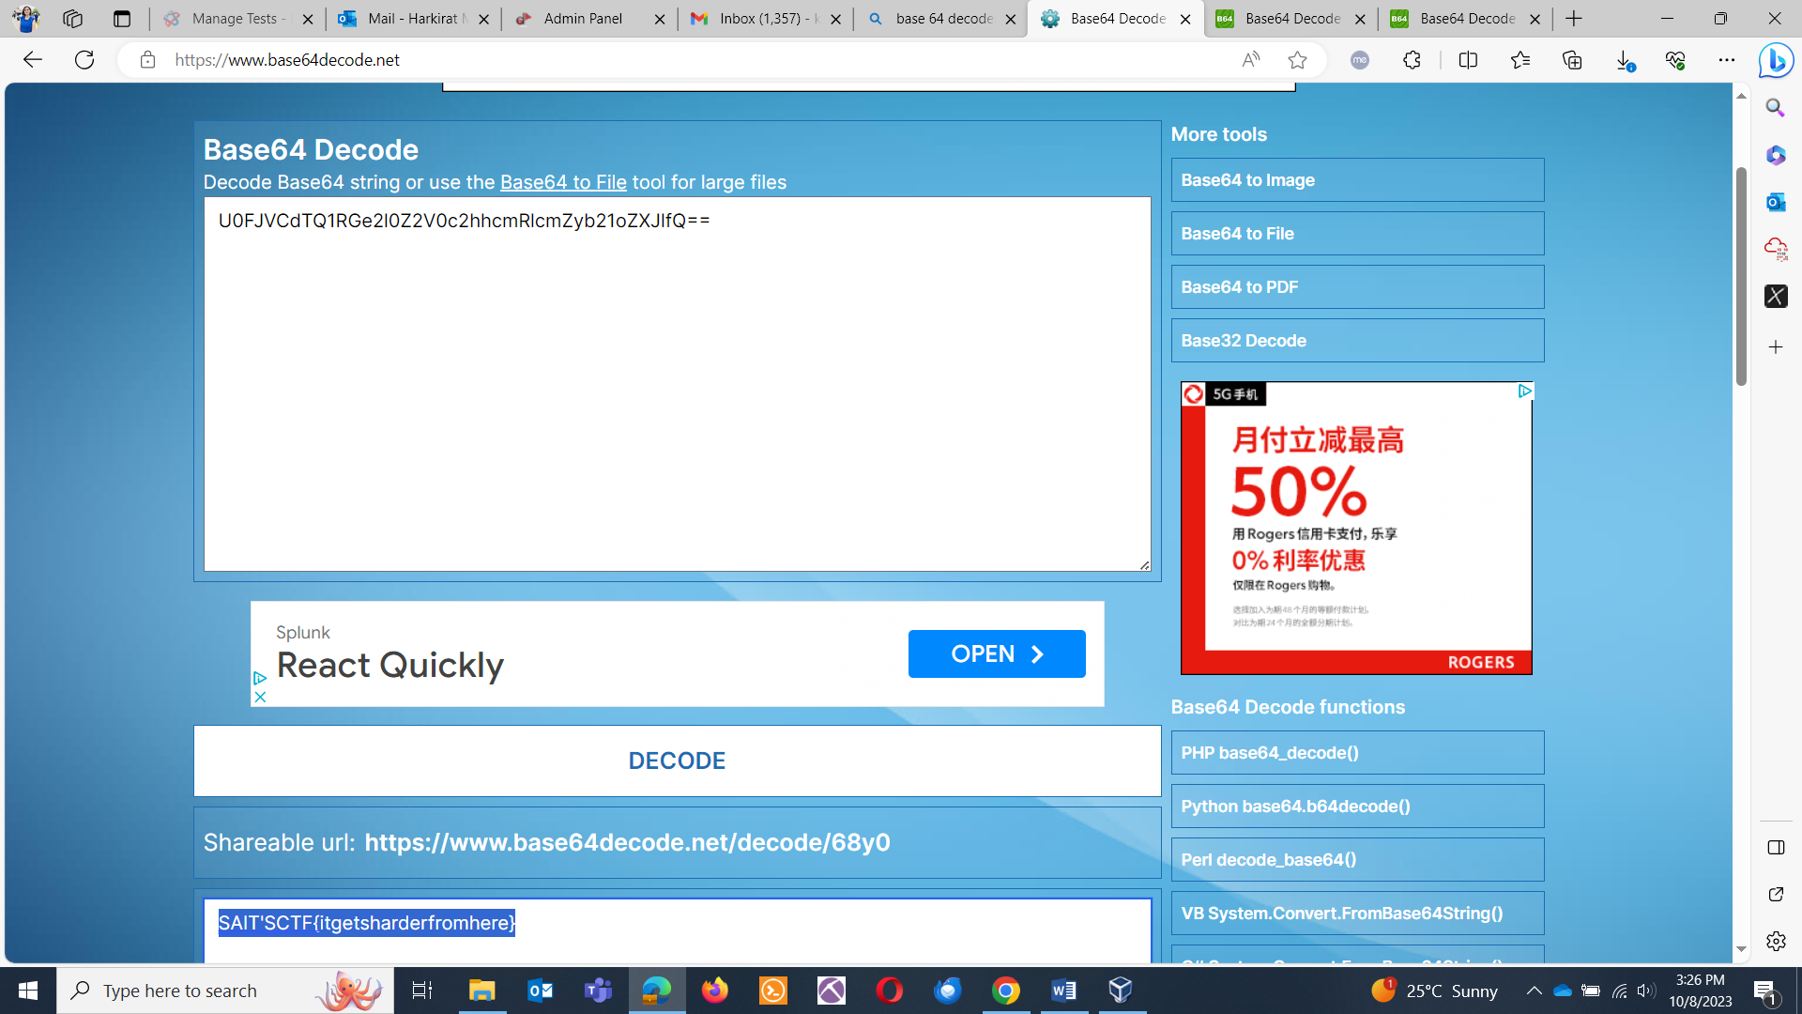

**PEEK INTO BINARY: REVERSE ENGINEERING**

QUES: In your hands lies a compiled program game, Can you unveil the size of program's header bytes,

Flag format: SAIT’SCTF{Xbytes}

ANS: SAIT’SCTF{56bytes}

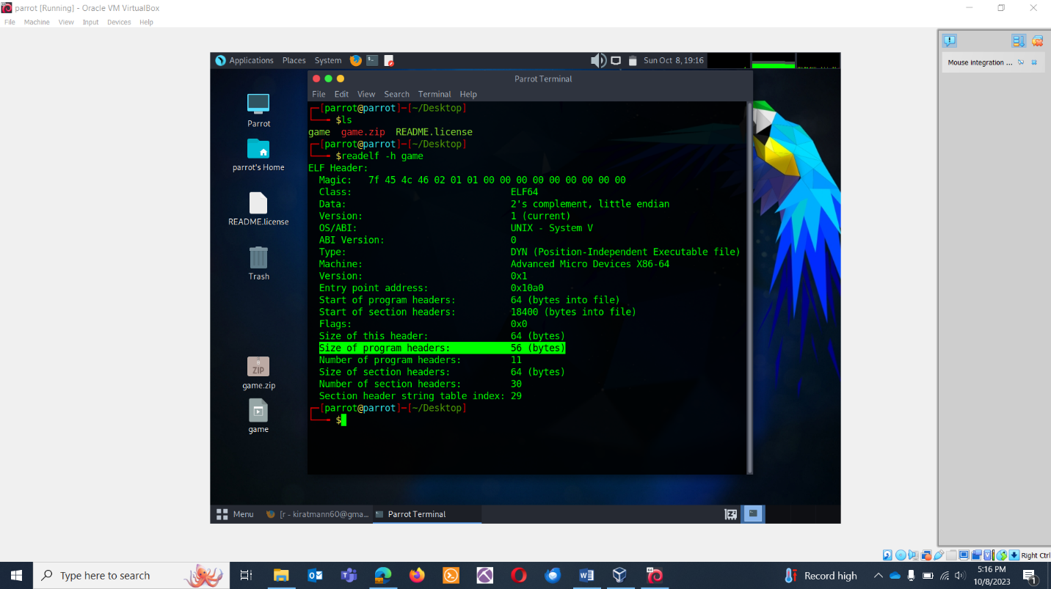

**SOLVE THE MYSTERY**

QUES: Here are your two components:

Email : Protect your Company, pull a code from it.

Program: Enter the code and pull the flag.

ANS: SAIT’SCTF{987654321}

Email analysis:

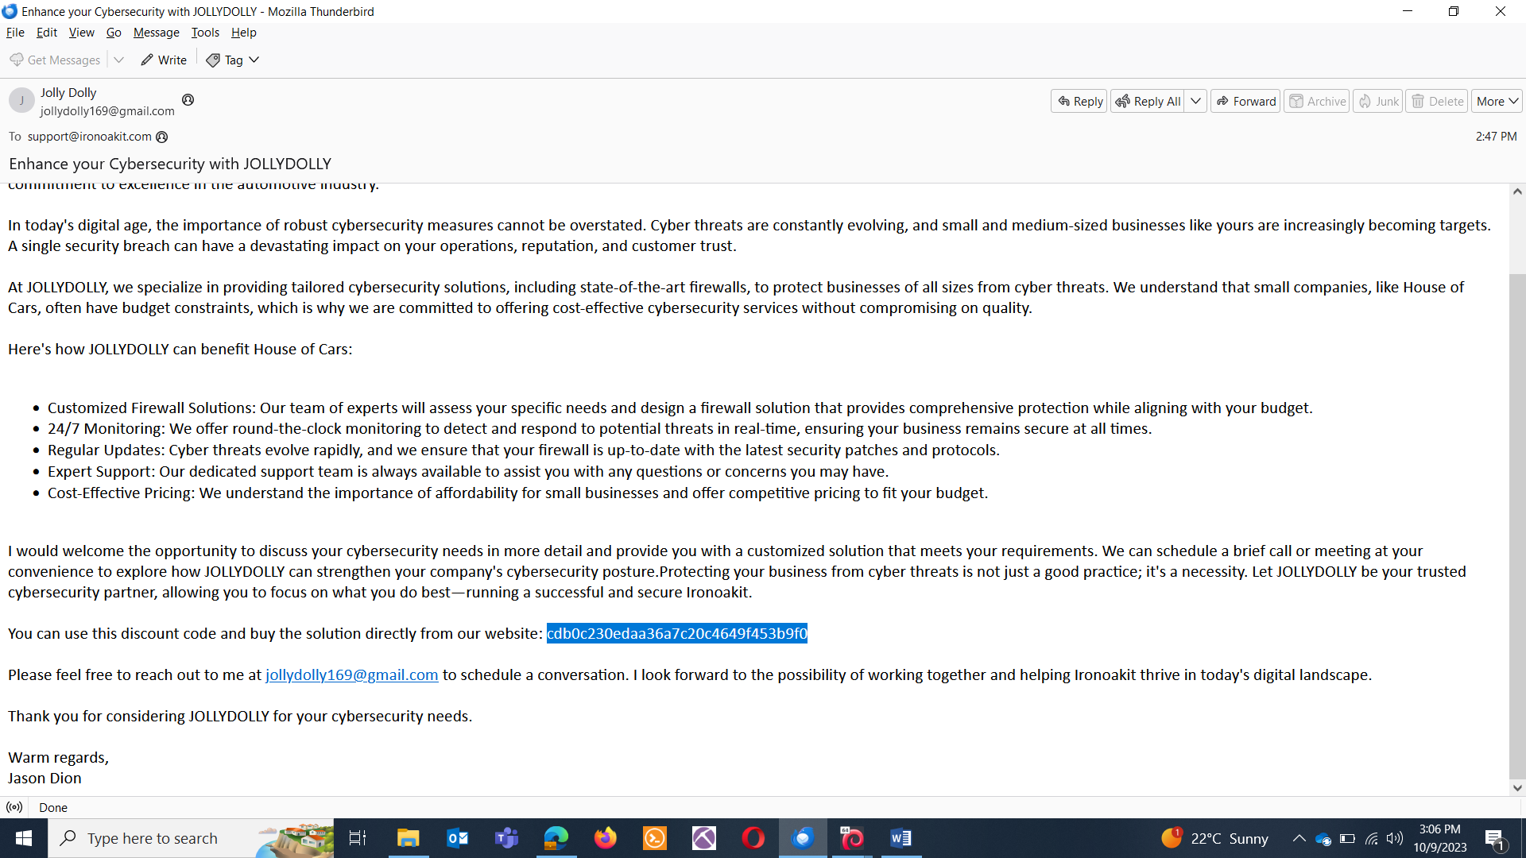

Pulling the hash and cracking: 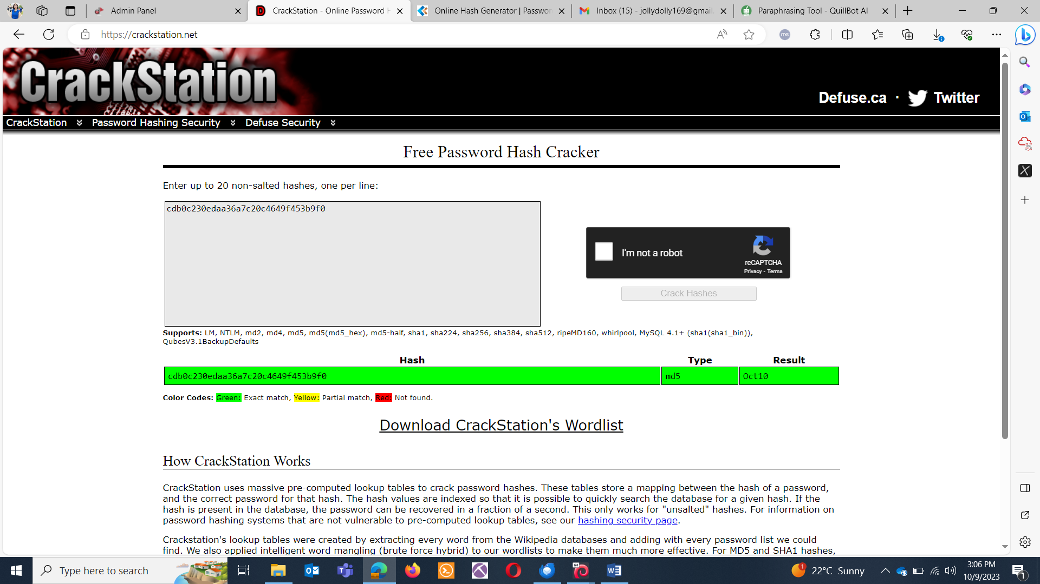

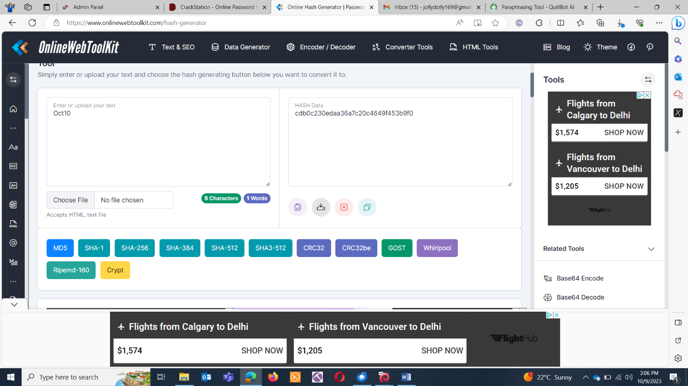

Heading towards the program:

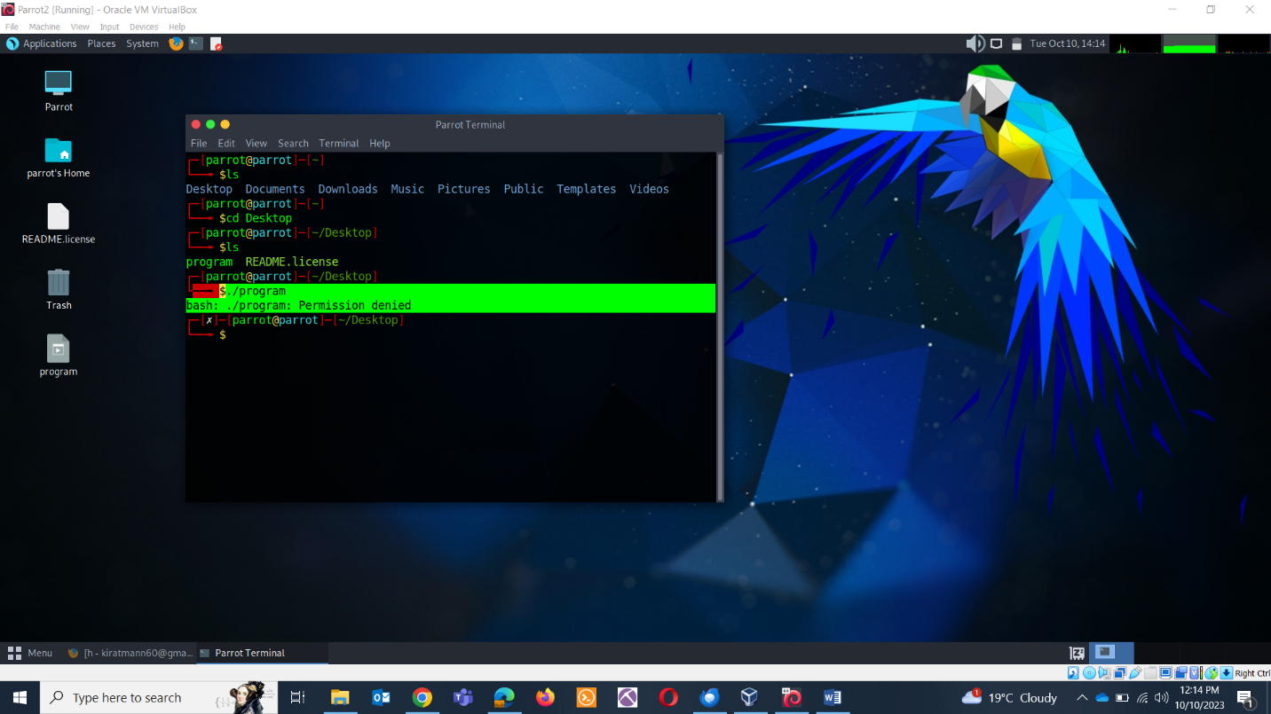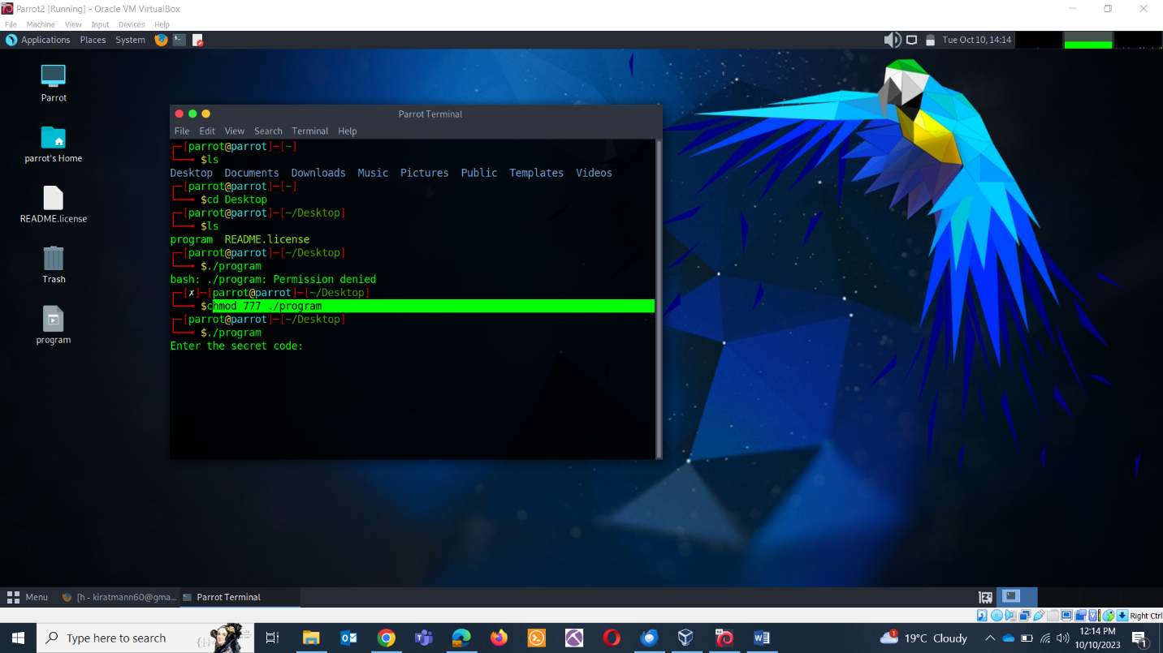

Pasting value in code:

